DSLR Cameras

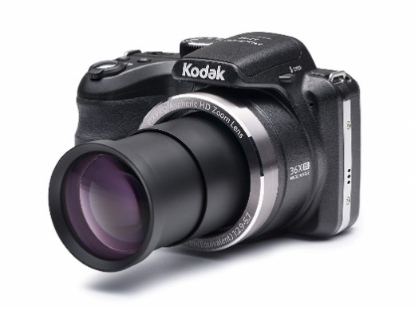
Kodak PixPro AZ361

36x Optical Zoom, 16MP CCD Sensor, 720p, Rechargeable Li-ion Battery, 24mm Wide Angle Lens. Will not provide phantom power

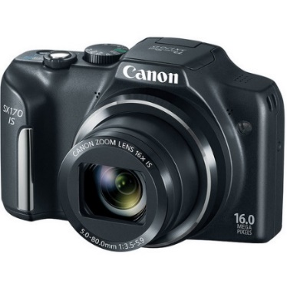
Canon SX170
16 Megapixel 1/2.3" CCD Sensor, 16x Optical Zoom Lens (28-448mm), 3.0" High Resolution LCD Screen, HD 720/25p Video with Movie Button Will not provide phantom power

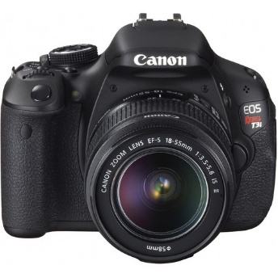
Canon OS Rebel T3
DIGIC 4 Image Processor and an 18.0 Megapixel CMOS Image Sensor, Full HD video recording, Live View shooting, Wireless flash photography and 3.0-inch LCD monitor, ISO 100 – 6400 (expandable to 12800) for shooting from bright to dim light. Records audio, has 1/8” mic jack, does not provide phantom power

Canon EOS Rebel T6
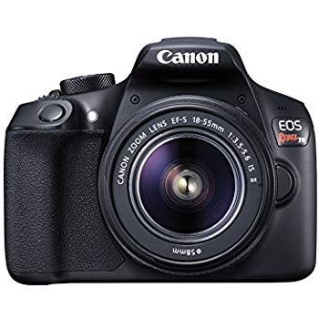
- 18.0 MP APS-C CMOS Sensor; DIGIC 4+ Image Processor; 3.0" 920k-Dot LCD Monitor
- Full HD 1080p Video Recording at 30 fps; 9-Point AF with Center Cross-Type Point
- ISO 100-6400 (expandable to H: 12800) for shooting from bright light to low light. 3 fps Shooting; Built-In Wi-Fi with NFC; Scene Intelligent Auto Mode
- High-performance Optical Viewfinder helps facilitate quick and accurate focusing by firmly framing and capturing the subject at hand. Will not record audio.

Canon EOS M50 Mirrorless
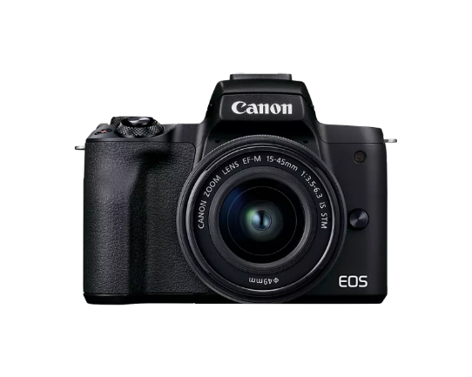
- 24.1MP APS-C CMOS Sensor
- DIGIC 8 Image Processor
- 2.36m-Dot OLED Electronic Viewfinder
- 3.0" 1.04m-Dot Vari-Angle Touchscreen
- UHD 4K and HD 720p120 Video Recording
- Built-In Wi-Fi with NFC, Bluetooth
- Dual Pixel CMOS AF
- Extended ISO 51200, 10 fps Shooting
- Combination 5-Axis Image Stabilization
- EF-M 15-45mm f/3.5-6.3 IS STM Lens
- Records audio, has 1/8” mic jack, does not provide phantom power

Canon EOS 80D
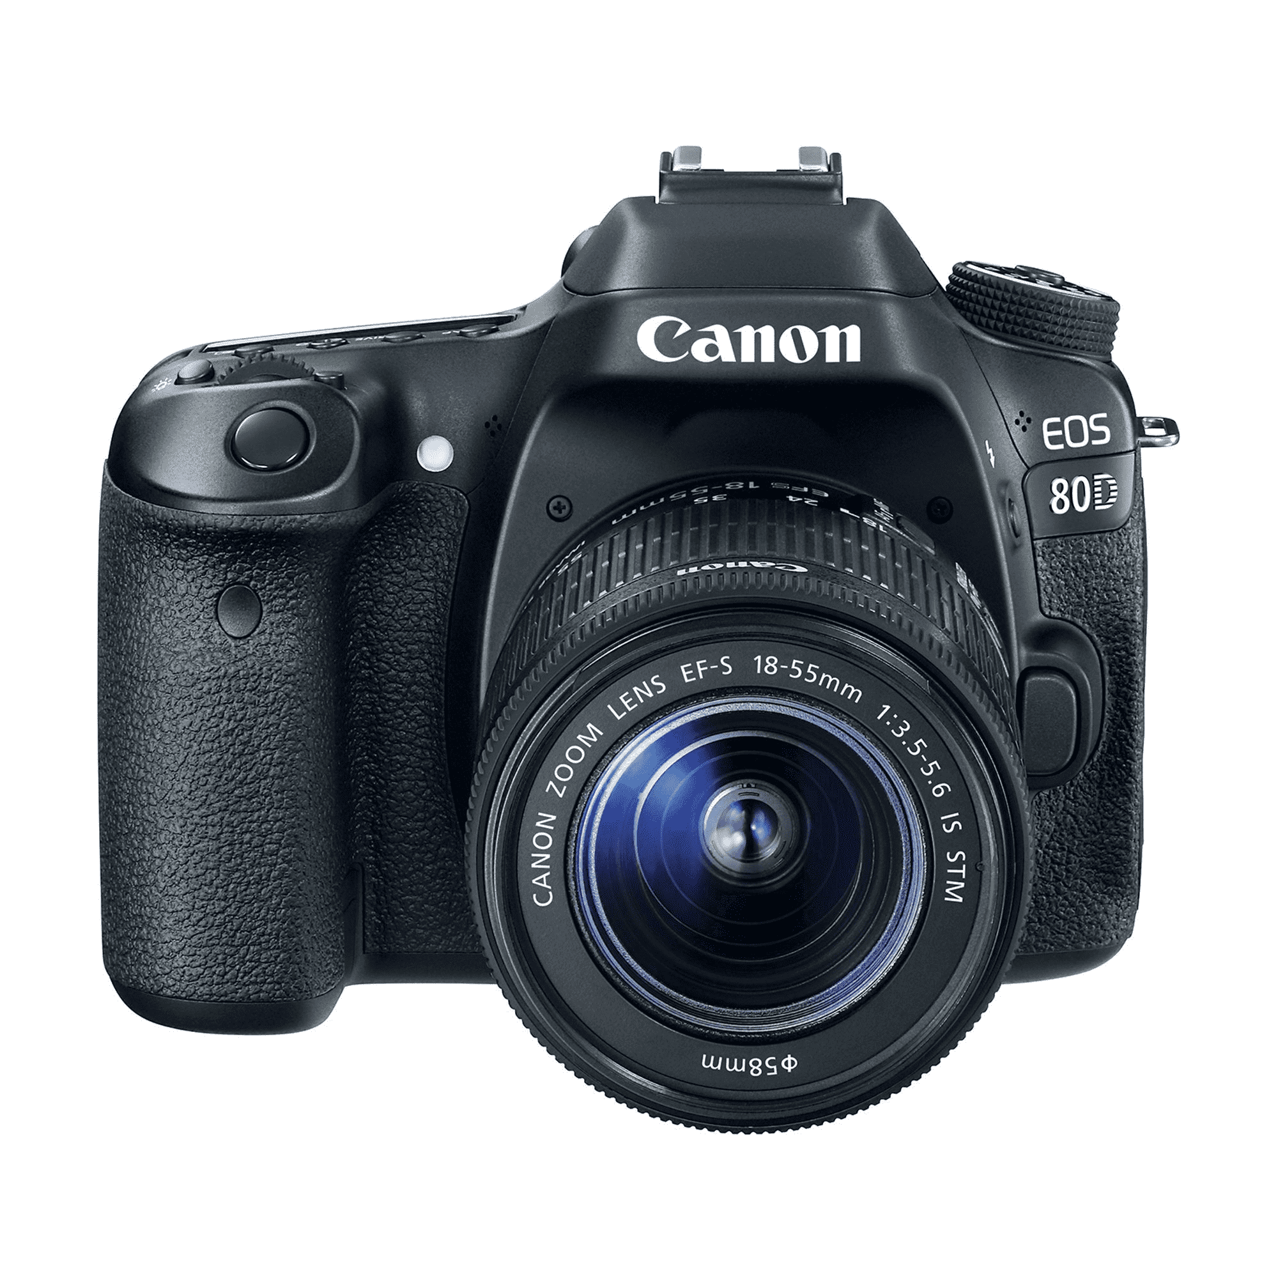
Versatile SLR features 45-point all cross-type AF system that provides high-speed, highly precise AF in virtually any kind of light. Intelligent Viewfinder with approximately 100% coverage provides a clear view and comprehensive image data. 24.2 Megapixel (APS-C) CMOS sensor and Dual Pixel CMOS AF for Live View shooting. Built-in wireless connectivity and Full HD 60p movies that can be saved as MP4s for easy sharing. 18-55mm lens and a 55-250mm lens. Will not provide phantom power

Lens Filters
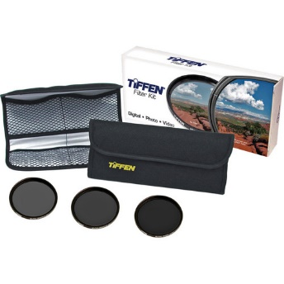
Tiffen Filter Kit 58mm Digital ND Kit; ND .6, ND .9, ND 1.2
To enable slow shutter speeds to be used, especially with high-speed films, to record movement in subjects such as waterfalls, clouds, or cars.
To decrease depth of field by allowing wider apertures to be used, which helps separate subjects from their background
To decrease the effective ISO of high-speed film (above ISO 400) and allow it to be used outdoors in bright situation
To allow cine and video cameras (which have fixed shutter speeds) to film subjects such as snow, sand, or other bright scenes that could cause overexposure.

Video Cameras

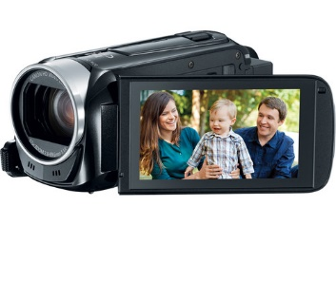
Canon Vixia HF R400, R500, R600, R800
The Canon VIXIA HF R400 Full HD Camcorder records Full HD 1920 x 1080p video directly to an SD/SDHC/SDXC memory card. For easy recording and instant playback, there's a 3" touch panel LCD as well. Will not provide phantom power

JVC GY-HM170UA 4KCAM Camcorder
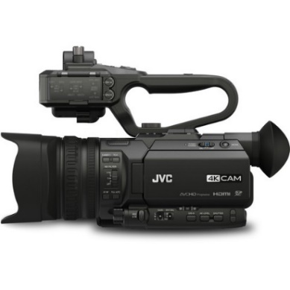
GY-HM170UA 4KCAM Camcorder Records UHD 4K in 24 or 30p, or 1080p at up to 60 fps, .MOV file, or in AVCHD for compatibility with consumer editing software.
Flip-out LCD screen, plus viewfinder. Built in ND filters. The top handle audio unit features two XLR audio inputs for use with external microphones, offering switchable Mic/Line/Mic +48 inputs with independent gain control. Provides phantom power.
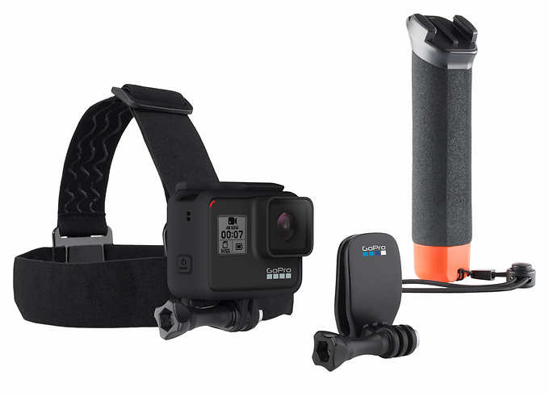
Go Pro Hero7
Film underwater scenes in 4K with this 12-megapixel GoPro HERO7 action camera. Its HyperSmooth stabilization feature lets you capture shake-free videos, and it withstands submersion up to 33 feet without a waterproof case. Stream captured videos from this rugged GoPro HERO7 action camera on Facebook Live via the companion app.

Drone; dji Mavic Air Model U11X
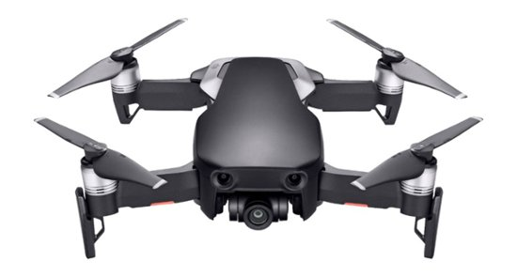

32.0MP sphere panoramas, 4K video at 30 fps

Slow Motion Video, Real-time, first-person view of your flight, dedicated remote controller, Safe flight, Active Track

**Requires successful completion of FCC’s The Recreational UAS Safety Test (TRUST) and user supplied compatible smart phone **

Camera Support

Video Tripods

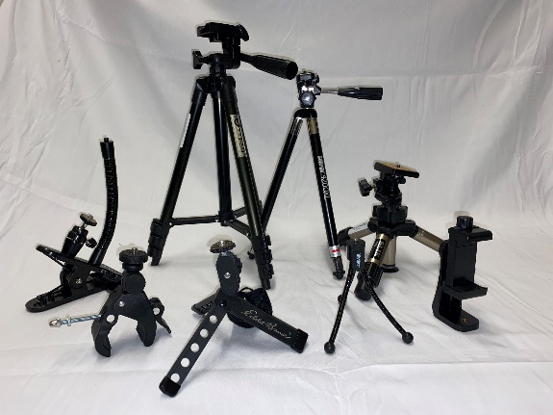
Desktop

Assorted Desktop tripods and clamps; Sunpack 4200XL, SLIK mini 8555, Vivitar, Eddie Bauer, smartphone adapters, SUPON Camera Super Clamp, Sunpack ClampPod Pro

Pro Level

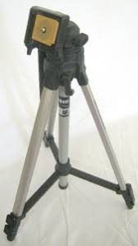
Assorted Lightweight tripods

Manfrotto 190X with MVH500AH or MVH502AH

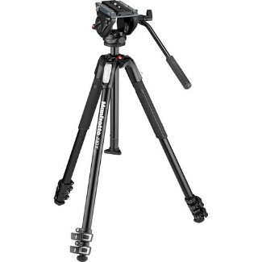
Fluid video head with a lightweight photo tripod. Supporting loads up to 11 lb, the system is ideal for use with DSLRs, mirrorless cameras, and compact camcorders. Working height of 27 to 57", with a maximum height of 67". For ultra-low operating heights, the center column can be replaced with an included ground-level adapter to get the mounting plate as low as 3.5" above the ground with the legs set to the widest angle. The MVH500AH head features a side-lock quick release plate system that allows for fast and efficient camera mounting from above, fixed fluid pan/tilt drag, and a pre-set 5.3 lb spring-loaded counterbalance. 502 Sliding quick release plate secured by secondary safety system

Manfrotto 546B with 504HD Head
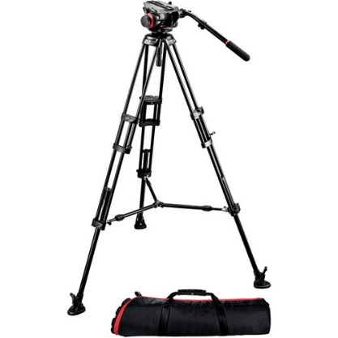
504HD fluid video head with the 2-stage aluminum 546B professional video tripod to create an ideal combo of affordability, stability, and smooth, precise control. This compact, versatile system was designed with independent video and DSLR shooters in mind, and it provides the level of ergonomics and support required by today's small crews and one-man bands. maximum height of 60.6”; 19.8 lbs. capacity

Photography Tripods

Smith-Victor 3 stage photography tripod

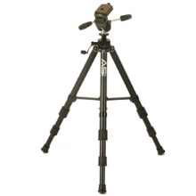
Three-way fluid effect head with dual handles

Neewer Carbon Tripod/Monopod
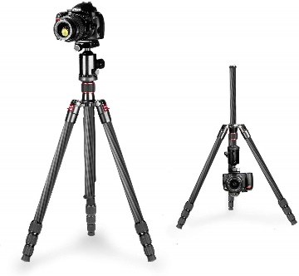
Neewer Carbon Fiber 66 inches Camera Tripod Monopod with 360 Degree Ball Head,1/4 inch Quick Shoe Plate,Bag for DSLR Camera,Video Camcorder,Load up to 26.5 pounds

Other Support

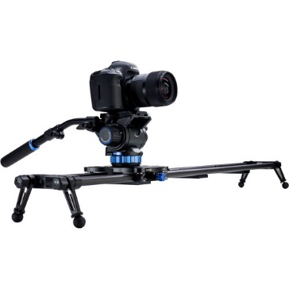
Camera Slider
Benro MoveOver8B Carbon Fiber Slider with 35.4" of actual carriage travel; features a flat mounting surface, 3/8"-16 for mounting flat base fluid head, and pre-tensioned roller bearings for a smooth glide. Built-in friction brake controlled by a single knob.

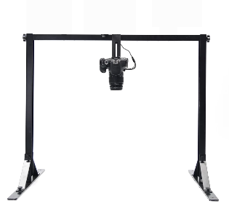
Overhead Camera Platform
Use the Overhead Camera Platform for photography applications such as:
•Photography of small objects such as jewelry or electronics.
•Photography typically requiring a complete vertical angle such as food pictures, assembly video, tutorial video or cooking video.
The Overhead Camera Platform:
•Can accommodate most DSLR and most lenses thanks to its vertical adjustment ranging from 15cm/6’’ to 50cm/20’’.

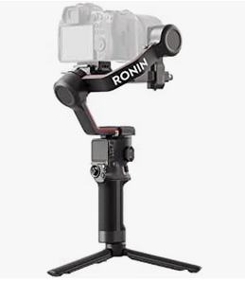
Ronin-SC dji Gimbal Stabilizer

- Dynamic Stability - Continuous stabilization; effective in fast follows, sudden motions, and even complete changes in direction.
- Automated Features - advanced capturing features to unleash your imagination.
- Easy to Handle - The buttons and trigger are easy to reach for every essential control.
- Requires iOS 11.0, Android 7.0 or above.

Osmo 2
Smartphone Gimbal built to film on the go. Select your subject and ActiveTrack will follow, using built-in sensors and a brushless motors to ensure stability. Whether it’s small vibrations from a skateboard or more intense instability from jumping, this smartphone stabilizer stays steady.
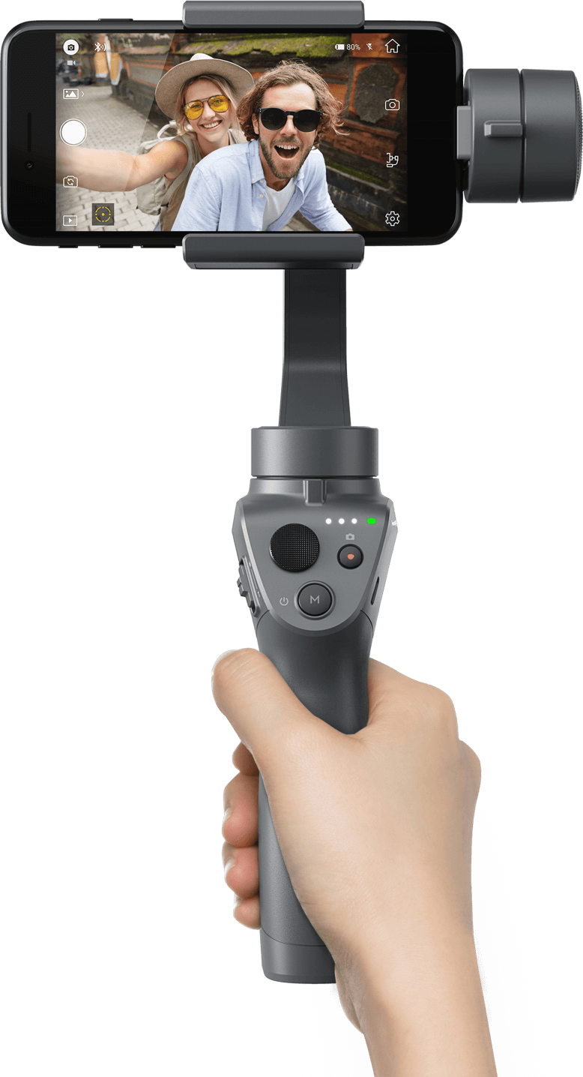

Stable and Smooth Moves

Cinematic Zoom Control

Lightweight and Portable

Time in Motion

**Requires Smart Phone and installation of app. Not compatible with all smart phones. **

Lighting

Dracast Halo Bicolor LED Ring light with Stand Kit
LED Halo light, 0% – 100% dimming capability using the dimmer knob on the ring light or with the included wireless remote. Includes phone mount.
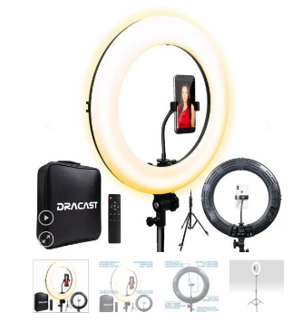
Nanlite Litolite 8F 5600K 8W focusable LED fresnel
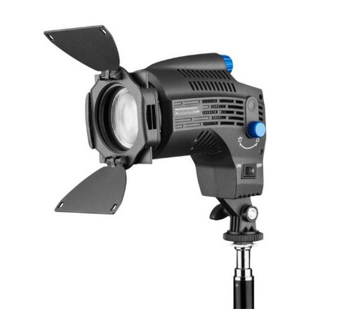
Focusable LED Fresnel. A compact, daylight balanced 8w LED light for use on a camera or tripod, which features flood and spotlight adjustment from 10-60 degrees, 0 to 100% dimming, a maximum output of 560 lumens. Mounts on camera or lighting stand.
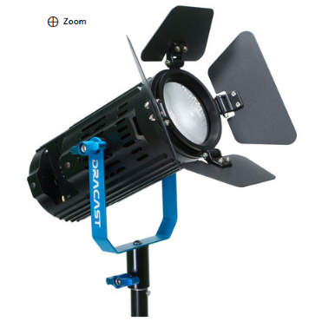
Dracast Boltray Plus LED Daylight Light
- 3200-5600K Adjustable Color Temperature
- CRI: 96, 4 Color Temperature Presets
- AC/DC Power Options, LCD Digital Display
- 110-240 VAC Power Adapter
- PWM Dimming Technology
- Virtually Silent Fan
Dracast 2 light kit, bi-color 3200k-5600k, batt/ac power
LED light; lux rating: 3082 lux / 286 fc @ 3.0' / 0.9m at 5600K
Max Power Consumption: 30w
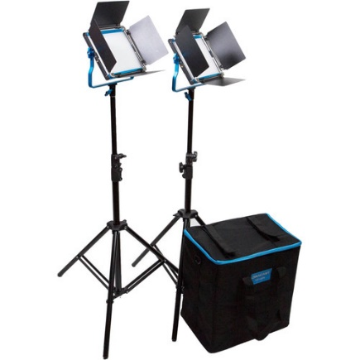

Dracast 3 light kit, bi-color 3200k-5600k, batt/ac power
LED light; lux rating: 3082 lux / 286 fc @ 3.0' / 0.9m at 5600K
Max Power Consumption: 30w
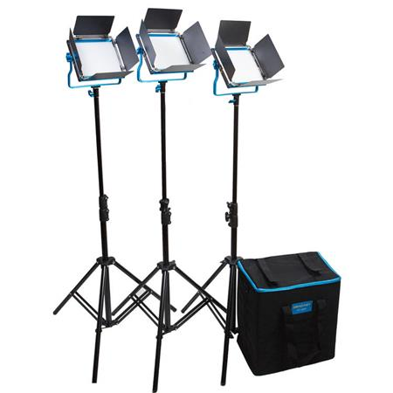

Westcott Ulite Impact 2 light kit, continuous light, AC power
Photoflood lamp – 500w, 3200k; kit = 1000w
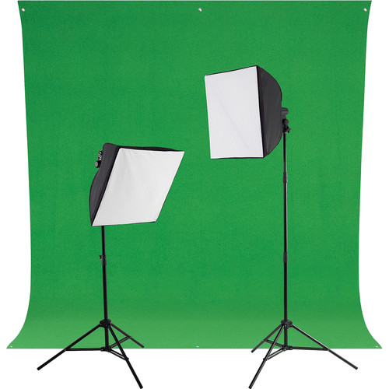

MiniBurst 128/256 3 point Light Kit – 5600k, batt/ac power
LED light; Warming Filter for 3200k or Soft Diffuser for 4200k.
128 = 100W equivalent output’ 256 = 200W equivalent; total kit 500W equivalent output
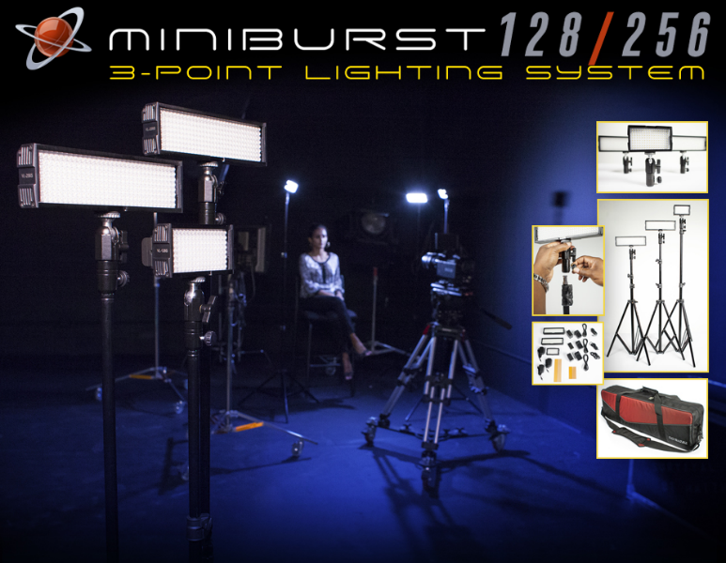

Lowel Light Kit 2 lights, AC power
Tungsten Flood; 750w; 3200k with shoot through diffusor umbrellas
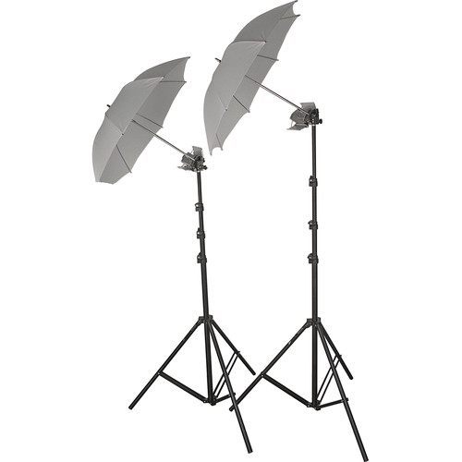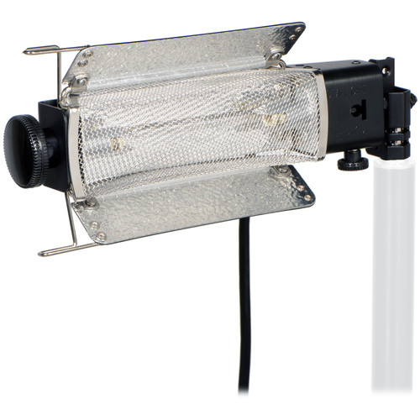
Shadow Kit – Digital Juice
Portable lighting modification kit
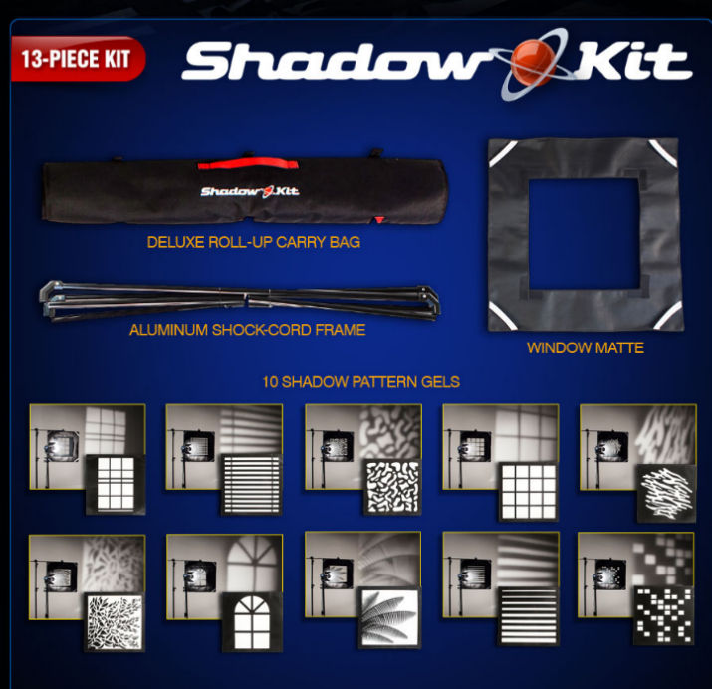
Create shadow patterns on your background or subject. A flatly lit wall can be broken up with light and shadow, mimicking the effect of dappled sunlight through leaves. Placed in front of a light source cast a variety shadows onto the background.

Road Rags Kit – Matthews
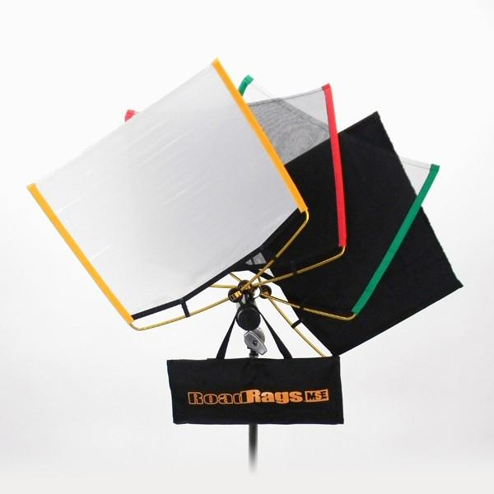
Matthews RoadRags Kit lighting modification system. By using the different materials, you are able to create contrasts, different light ratios, diffuse or block the light.
RoadRags are designed for use under a controlled environment. Wind and/or other weather conditions may cause damage to this product.

Reflector

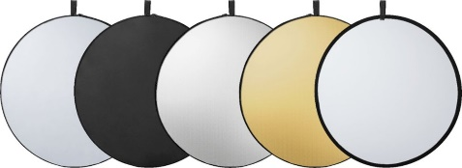
5-in-1 42-inch collapsible light reﬂector provide several different light effects

Grip
C-Stand
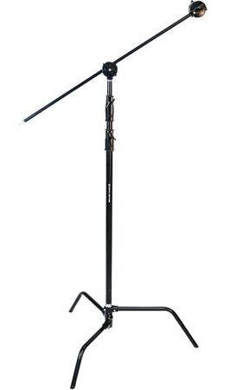
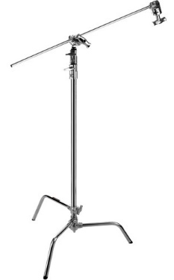
C-stand (or Century stand) is primarily used to position light modifiers, such as silks, nets, flags, or reflectors in front of light sources. The legs of C stands are designed to be nested, so many stands can be placed around a light source. **It’s a good idea to drop a sand bag on the base for stability.

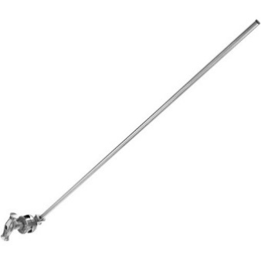
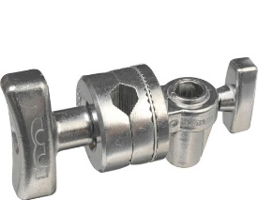
Gobo arm, Extension Arm, Knuckle, Gobo head,
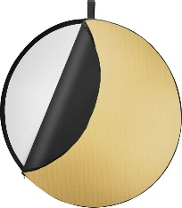
The arm and grip head may be used for small fixtures, positioning of gobos, flags or reflectors. . **It’s a good idea to drop a sand bag on the base for stability and counterbalance weight may be necessary.

Mini Grip – Matthews
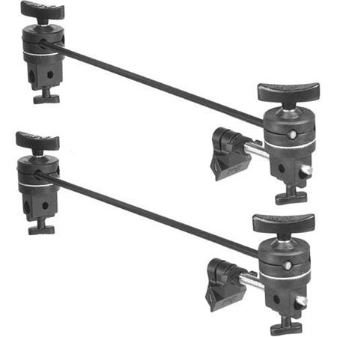
The Minigrip Kit is used with camera attachments and other accessories as well as lighting equipment. These miniature tools are ideal for tabletop photography, car interiors, and otherwise confined areas.

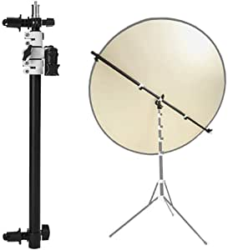
Reflector Stand
Multipurpose stand - can hold a light, a bounce reflector, a flag, or a Cookie. **It’s a good idea to drop a sand bag on the base for stability and a counterbalance weight may be necessary.

Teleprompters
Listec Promptware PW-04
Smartphone teleprompter – up to 58mm lens; Android iOS compatible – requires smartphone and app. (up to 4.5” tall)

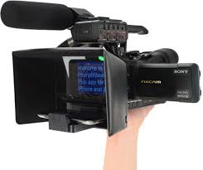

EZ Prompter Paper tray (with iPad/iPhone plate)
Requires smartphone or tablet and app

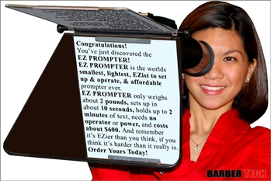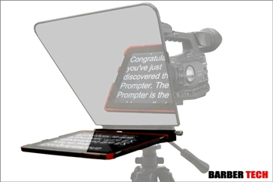

Audio
AUDIO RECORDERS (digital only)
These portable audio only recorders have a varying number of separate inputs or tracks. It is common in the film industry to record audio separately from film and combine in editing.

Tascam DR-22WI Field Recorder
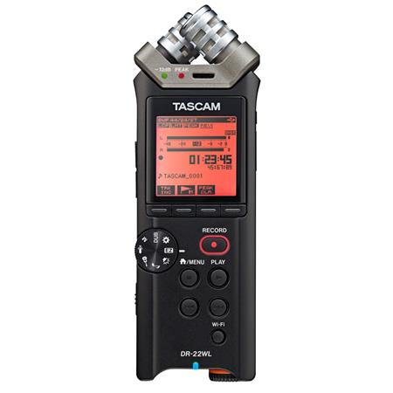
.WAV, 44 kHz, 16-bit, XY Mics, w/ 4GB Mini SD Card, 2 AA Batteries, Mini USB

ZOOM F1 Field Recorder
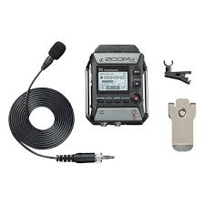
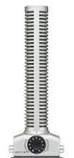
Lavalier, Shotgun, windscreens, 1/8" patch cable, Cam Mount, 32 GB Mini SD, AAA batteries

ZOOM H2n Field Recorder
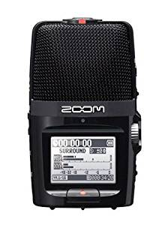
.WAV, 44.1KHz, 16-bit, Surround/Stereo, SD Card w/ 2 GB, 2AA Batteries, Tripod Stand, Remote, Windscreen, Charger, Mic Clip Adapter

ZOOM H6 Field Recorder
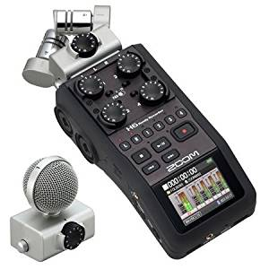

6 Input, 6-Track Portable Recorder with Interchangeable Mic Capsules, .WAV .MP3, 96Khz 48+44.1Khz, 16-bit Charger, 16GB USB Card, Windscreen, USB2

Microphones
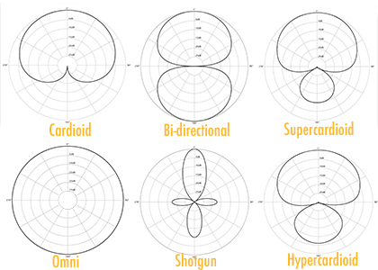
*Mics are wired and not wireless unless otherwise noted.

Microphones for Video Production
Lavalier Mics
Electra-Voice C02 (1)
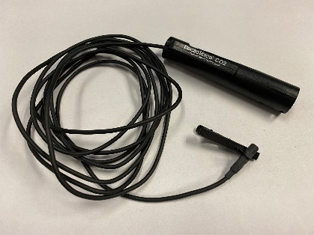
Miniature Condenser Lavalier Mic. Omnidirectional Polar Pattern, well balanced, clean sound reproduction. Requires Phantom Power

Sony EMC-44B (1)
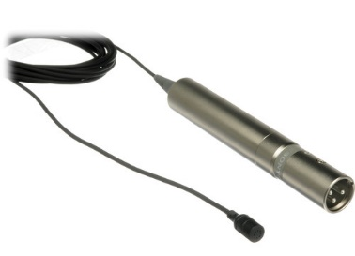
Clean, bright, natural reproduction. Operates on a single AA (does not accept phantom power) battery.

Shotgun Mics

Audio-Technica AT875 (1)
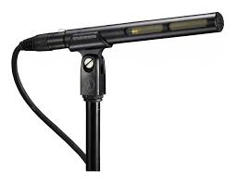
Short shotgun, video production, Phantom Power Required. Designed for video production and broadcast (ENG/EFP) audio acquisition. Provides the narrow acceptance angle desirable for long-distance sound pickup. Excellent sound rejection from the sides and rear of mic. Good choice with HM170 camcorder.

Audio-Technica AT897 (2)
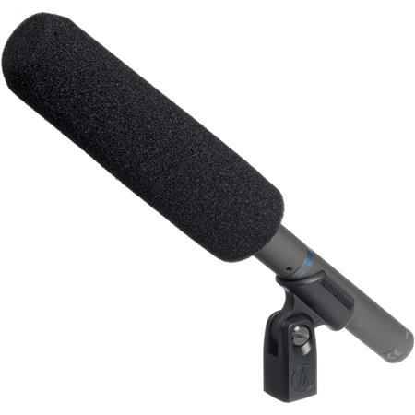
Designed for video production and broadcast (ENG/EFP) audio acquisition. Short length (11") ensures mic stays out of the shot -- even when used with compact digital cameras. Smooth, natural-sounding on-axis audio quality. Provides the narrow acceptance angle desirable for long-distance sound pickup. Excellent sound rejection from the sides and rear of mic. Switchable low-frequency roll-off. Operates on battery or phantom power

Wireless Lav/Handheld
Both the mic and the receiver work on battery power; often used for “field recording”, interviews, or ENG style video work.

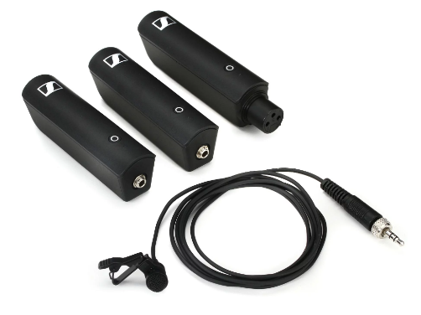
Sennheiser XS Digital ENG Set

TX XLR transmitter, TX 35 transmitter, RX35 Receiver, Belt clip, hotshoe mount, 1/8” coiled cable, USB C charging cable. Good choice with DSLR or consumer camcorder.

RODE Wireless GO
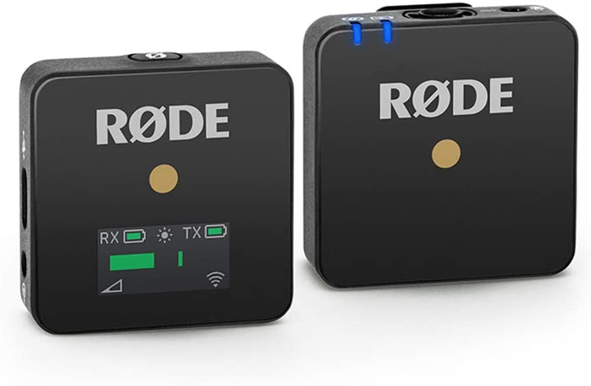
Use with cell phone, DSLR or any recording device with 1/8” audio input. Easy to use combo clip-on microphone with beltpack transmitter for lavalier/headset mic/ built-in omnidirectional condenser mic for broadcast-quality sound. Power TX and RX have built-in USB-C rechargeable batteries/ up to 7 hours on a full charge including a battery Saver mode. Portable super-lightweight and ultra-compact

Bluetooth Microphones

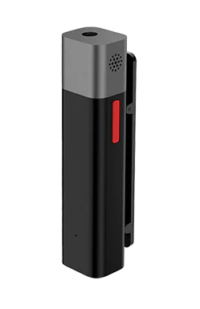
Use with cell phone (Android or iPhone) or compatible DSLR.

Wireless Bluetooth Clip-on Mic

Multi-Level Ambient Noise Suppression

Real Time in-ear Monitoring

Compact and Light weight

Multifunctional Wireless Microphone

