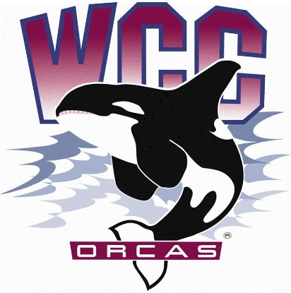
ASWCC InterClub Council Meeting Minutes
Date: October 27th, 2023
Location: Syre 216

Meeting call to order at 9:04 a.m
Land acknowledgement and pronoun statement
- Whatcom Community College is situated on the land of the Coast Salish People, including the Lummi, Nooksack, Semiahmoo and Samish. The land was stolen through broken treaties. We honor the people who cared and continue to care for the land, water, air and more since time immemorial, and we recognize our responsibility in giving back and beginning to repair and rebuild relationships in our work. This is one small statement, but we hope our impact will be greater.
- We share our pronouns to strengthen our human connection, to show respect to aspects of identity, and as an invitation for community. We understand the fluidity of identity and expression; Therefore, we share pronouns in all introductions to create a supportive environment for learning and leading.
Introduction of Fully Chartered Clubs
- Desdemonda Ruud – President of Volleyball Club
- Anthony Stock – Co-President/ Officer of Sustainable Oriented Students (S.O.S) Club
- Ethan Aldrich – Secretary of Sustainable Oriented Students (S.O.S) Club
- Trevor Austin – Co-President of Japanese Club
- Jovanka Wong – Secretary of Badminton Club
- No representative – Campus Christian Fellowship (CCF) Club
Meeting purpose
- The InterClub Council meeting serves as a platform for Chartered Clubs to collaborate, discuss funding request, share updates, and coordinate various activities to enhance the campus engagement and facilitate the growth of the ASWCC club community
Meeting expectations and Rules
- Utilization of Robert’s Rules of Order for a fair and structured meeting
- Use of Club name tag cards to signal a desire to speak (facing upwards)
- State your name and the club you are associated with when speaking
- Open floor for discussion before voting or when needed
Approval of Agenda
- Matthew asked for motion to approve the agenda
- Anthony moved to approve the agenda - Desdemonda seconded
- Unanimous vote – Agenda is approved
InterClub Council Budget Report
- Question about Orca Day
- Matthew went over club’s budget
- Anthony asked about the differences between this year and last year’s budget
New business
Social Media Marketing – Club of the week
  - Matthew opened for discussion
  - Suggestion for adding club’s photos on social media
  - Desdemonda as a member in Student Life and Engagement Team can make interviews for the representative of clubs to advertise for their clubs
  - Club takeover on social media, provide behind the scenes of club’s events, Feedback Friday
  - Matthew asked for motion to approve “Club of the Week”
  - Ethan moved to approve Club of the Week - Trevor seconded
  - Unanimous vote – Club of the Week is approved
Other Club Initiatives (e.g., Talent Show)
  - Went over the Talent Show that Trevor brought up
  - Questions surrounding Talent Show
  - Trevor suggested that there can be a talent show to advertise clubs and a talent show for individuals of clubs to showcase their talent
  - Suggestion for committee member to take a lead in the event, and that person can ask for funding
  - Reminder not to make assumptions and speak on behalf of other clubs
  - Clarified that clubs can use their money to advocate and advertise themselves
  - Matthew asked what ideas or food options should be at the Variety/ Talent Show
  - Reminder not to plan events during the meeting, but can have discussion
  - Trevor motioned to approved the event - Anthony seconded
  - Unanimous vote – The Variety/ Talent Show is approved
Comments and Concerns to better serve Chartered Clubs
- Suggestion to use Marketing Kit and clarified that it is a 1-time offer
- Update club webpage and contact information
- Discussion for having matching posters for each club at the InterClub Council
- Suggestion to have reports regarding
  - Chartered Clubs
  - From Matthew as a member of the Executive Board and from the Student Life and Engagement Team members
  - ASWCC Student Unions
  - Advisor
- Conversation related to ASWCC Club President Leadership Retreat
Reminders
- Maintaining Active Status
- Next InterClub Council on November 17th (Funding request 1 week advance, deadline: November 10th)
- Quarterly reports (due November 27th)
Meeting call to adjourn at 10:04 a.m

