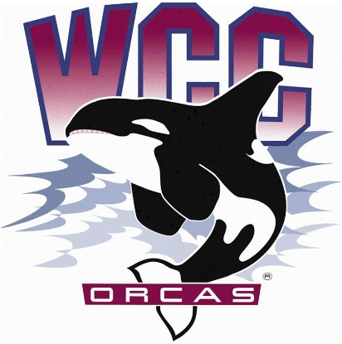
ASWCC Executive Board Meeting Minutes
Date: October 23rd, 2023
Location: Syre 108

Alaina Hirsch – ASWCC President, chair
Voting members
- Krystan Andreason – ASWCC Vice President for Campus Advocacy
- Matthew Valencia – ASWCC Vice President for Clubs
- Bella Nguyen – ASWCC Vice President for Operations
Meeting call to order at 3:02 p.m
Land acknowledgement and pronoun statement
- Whatcom Community College is situated on the land of the Coast Salish People, including the Lummi, Nooksack, Semiahmoo and Samish. The land was stolen through broken treaties. We honor the people who cared and continue to care for the land, water, air and more since time immemorial, and we recognize our responsibility in giving back and beginning to repair and rebuild relationships in our work. This is one small statement, but we hope our impact will be greater.
- We share our pronouns to strengthen our human connection, to show respect to aspects of identity, and as an invitation for community. We understand the fluidity of identity and expression; Therefore, we share pronouns in all introductions to create a supportive environment for learning and leading.
Approval of agenda
- Krystan moved to approve the agenda
- Matthew seconded
- Unanimous vote – Agenda is approved
Introduction of 2023-2023 ASWCC Work Plan Draft: Discuss suggested features of Work Plan and add or edit draft based on collaborative feedback
- Alaina clarified that the Programming and Diversity Board will no longer be on the work plan
Engagement: Organizing events and programming to engage students and foster a sense of community while they pursue education and personal development
- Suggestion about adding committees that do programming work like Social Justice Committee, Health & Wellness Committee. And organizations that provide students’ programming such as Student Life and Engagement Team, Intercultural Center, Peer Navigators, Athletics, Horizon...
- Clarification about the Executive Board’s work amongst other departments
- Matthew suggested including ASWCC Student Unions for Engagement
- Matthew brought up the Orca Volunteer Program from 21-22 work plan. Heidi reminded the Executive Board that the Bylaws are being amended so it is unsure who oversees the Orca Volunteer Program for this year, it might be the VP for Operations
- Discussion on working with League of Women Voters to encourage civic engagement and remain a Voter Friendly Campus – Heidi clarified that Executive Board members can work with the organization without a specific designation
- Alaina would like to table this topic related to voting
Advocacy: Amplify student voices as we represent their interests through the lens of Inclusion, Diversity, Equity and Access (IDEA)
- Alaina went over previous conversation with the Intercultural Center Peer Navigators from the Executive Board Panel, that low wage provided barriers to some students. And the unbalanced between the required works within specific working hours
- Heidi suggested looking into the budget before considering changing wages
- More specific for “student staff”
- Alaina hope that both the Executive Board and the Student Life and Engagement Team can take on workshops and seminars
- Clarification that some of the workshops have already been done by the college. Suggestions on talking to faculties and staffs who are willing to help and volunteer in training students for specific goals
- Matthew asked about including TRIO – Heidi clarified that TRIO programs are not always open to non-TRIO students, suggested talking to the new dean of students’ success
- Krystan said that the resume writing workshop is not currently in the Learning Commons, so she will look more into that. And that the budget for the Writing Center is decreasing due to advertising
- Alaina asked for more recommendations for skills that should be introduced to students
  - Interview skill
  - Professional communication
  - Workshop on how to use money – Finance literacy
- Krystan wanted to see advocacy for accessibility on the work plan
- Conversation about gender neutral bathrooms, showers, and lockers in the SRC
Legacy: Create and maintain sustainable programming and procedural infrastructure while honoring the work of past student leaders and constituents
- Having the conversation with members of the Student Life and Engagement Team to work together to develop the mobile app, and bring in students’ insights for that
- Questions about the app’s functionality and the progress in launching
- Recommendation to ask Lexus about operating arts competition
- Suggestion for making a committee for this – Heidi said to wait for more Senators
- A draft request for having a fridge in the Orca Food Pantry has been sent
- Suggestion for having a sink in Syre second floor
- Heidi drew attention to the 2 most important legacies which are the Orca Food Pantry and the mobile app, suggested talking to the foundation for help and support
Open positions: Discuss open positions, current applications, and options for moving forward the hiring process
- Alaina went over the open positions in the ASWCC Student Body: Executive Board, Coordinators, Event-support, Senators
ASWCC Hub App: Information on what the software is capable of, where we are now, and strategic planning for future use
Students Leading Change Conference: Review information on prior SLC Conference and consider themes for this year’s event, as well as possible guest speakers
- Krystan mentioned looking back at the previous SLC Conference in burrow but there was lack of timeline and themes. Thinking about inviting local speakers, instructors, the theme may be “Belonging”
- Matthew asked about bringing clubs
- Krystan asked for permission to put Social Justice Committee and Health & Wellness Committee on the campus calendar
Advisory report – No
The meeting is called to adjourn at 4:47 p.m

