Welcome to Cedar Hall!

Community Living
Cedar Hall is designed to build community. Individual living spaces are compact, encouraging students to use common areas and engage with fellow residents. The Cedar Hall community is centered on building positive relationships with each other and the environment.
We look forward to having you as a member of the Whatcom Community College housing community. Our Housing and Residence Life Education Program is designed to create a dynamic living experience for students to engage with peers. Our goal is to create a community of sustainable practices, inclusive understanding of everyone’s unique identity and experiences as well as an attitude of accountability to each other.

Here are some ways you can become engaged in Cedar Hall:
- BUILD COMMUNITY. Get to know the other residents on your floor and throughout the building.

- BUILD EQUITY. Our residents are from all around the world and all walks of life. Take this opportunity to gain experience from each other. Treat everyone with respect and kindness.

- ENGAGE. Participate in programs and events. Use your voice. Get involved!

- SET YOURSELF UP FOR SUCCESS. Feel free to ask us for help. Residence Life staff knows how to connect you with campus and community resources.
The following sections contain valuable information aimed to make your housing experience at WCC more rewarding. It is your responsibility to read, understand and follow the policies outlined in this handbook.
If you have questions or if there is anything we can do to make your stay more positive, just let us know. We are here to help. Residence Life is happy to welcome you to Cedar Hall.

CEDAR HALL STAFF
Director for Community Standards and Residence Life – Terri Thayer
The Director for Community Standards and Residence Life is responsible for the administrative leadership of student housing and ensuring that the department is providing a safe and positive residential living experience. This includes supervision of professional staff and overseeing the student conduct process.
Office Hours: Monday - Friday 8am-5pm Phone: (360) 383-3073
Location: Cedar Hall Office Email: tthayer@whatcom.edu
Residence Life Manager – Mo Whalen
The Residence Life Manager is responsible for the operations of Cedar Hall, including resident services, facilitating maintenance needs, billing, and following up on student payments. This position also manages conduct cases related to Residence Life policies and procedures.
Office Hours: Monday - Friday 8am-5pm Phone: (360) 383-3071
Location: Cedar Hall Office Email: mwhalen@whatcom.edu
Residence Life Coordinator
The Residence Life Coordinator (RLC) is a live-in staff member responsible for supervision of the Resident Advisor staff and provides oversight for Residence Life programming. This person is on call for after-hours emergencies.
Office Hours: Monday - Friday 10am-5pm-on call Phone: (360) 383-3150
Location: Cedar Hall Office Email:
International Housing Case Manager- Chelsea Van Dyke
The International Housing Case Manager is responsible for attending to the international residents in Cedar Hall. This person works with the Residence Life and International Programs departments to assist with coordinating day to day operations.
Office Hours: Monday - Friday 8am-5pm Phone: (360) 383-4971
Location: Cedar Hall Office Email: cvandyke@whatcom.edu
Resident Advisors
Resident Advisors (RAs) are a team of student staff members who each live on an assigned floor and work to develop a sense of community throughout the building. RAs assist residents with questions, concerns, and connections to campus resources. RAs also enforce Residence Life policies. There is an RA on call in Cedar Hall 24/7.

TABLE OF CONTENTS

community living 2
welcome to WCC 5
living options 5
non-discrimination 6
Community standards 9
Student rights and responsibilities.

conduct process 10
taking care of your space 11-12
OCcupancy……………………….15
Roommate requests, eligibility, payments, consolidation, and cohabitation policy, room change policy, checking in, what to bring, inspections, checking out
roommates, guests, quiet hours 16
services and amenities……. 17-19
Services, amenities, accommodations,
and maintenance of facilities.
safety 22-31
This section covers what to do in the event of a crime, sexual assault, drug or alcohol overdose, medical emergency, or natural disaster, as well as general safety tips, and campus alerts
policies & procedures 13-16 & 32-33
Bicycles, restricted areas, smoking and vaping, drugs and alcohol, weapons

Non-Discrimination Statement
Whatcom Community College does not discriminate on the basis of race, color, national origin, religion, sex, disability, honorably discharged veteran or military status, sexual orientation, gender identity, gender presentation, ancestry, ethnicity, family status, immigration status, citizenship, socioeconomic status, genetic information or age in its programs and activities.
The following person has been designated to handle inquiries regarding the non-discrimination policies: Executive Director for Human Resources, by phone: 360.383.3400 or email: hr@whatcom.edu , 237 W. Kellogg Road, Bellingham, WA 98226.
For Title IX compliance: Title IX Coordinator, by phone: 360.383.3400 or email: titleIX@whatcom.edu , 237 W. Kellogg Road, Bellingham, WA 98226.
WCC publications are available in alternate formats upon request by contacting the Access & Disability Services office at 360.383.3139; or Video Phone at 360.255.7182.

Living options
Welcome to Cedar Hall, WCC’s on campus residence hall. This state-of-the-art building includes four floors of living and communal gathering space with a combination of studios, one-, two- and four-bedroom suites that offer private bedrooms and shared living space and bathrooms.
Units include:
- Private bedroom
- Extra-long twin bed
- Desk with chair
- Built-in closet
- Kitchenette with microwave, stovetop, and refrigerator
- Ovens are available in the 1st floor community kitchen and fourth floor lounge
- Wi-Fi
- Smart TV and seating in the living room

Suite layouts
Studio

2 Bedroom

4 Bedroom

Eligibility
Residence Life housing is open to students who meet the eligibility requirements listed below. Applications for housing are processed on a first come, first serve basis according to the day and time the completed application is received.
- Applicant must be 18 years of age by the date of move-in.
- Applicant must pass a WCC conduct history check.
- Applicant must pass a criminal background check.
- Resident must be enrolled in a minimum of 5 credits at WCC.
- Resident must remain in good standing with WCC as defined in the conduct code.

room assignments
Room assignments are made based on the information applicants provide in their application. Residence Life Staff will attempt to notify existing residents at least 48 hours prior to the move in of a new roommate into your suite.

roommate requests
Residents may request a specific roommate, and Residence Life will attempt to honor these requests when possible.

gETTING PREPARED

What to Bring
The bedrooms and living spaces in Cedar Hall are small with limited storage space. It is important to bring only the items that you will need to live comfortably in your space. A minimalist lifestyle will serve you well in Cedar Hall. Below is a guide for what to bring and what not to bring when you are moving in.

Things to Bring/Purchase on Arrival
- Bedding, including XL twin sheets
- Toiletries
- Towels

DO NOT BRING
Additional room furniture
- Dressers/Mattresses/Tables
Candles/incense
Open coil halogen lamps
Nails or other invasive wall fasteners
Pets *except for a service animal or approved ESA
Drug/alcohol advertisements
Offensive/targeting decorations
- Items that a reasonable person would find offensive or that target a specific group of people
Strip lights
Weapons capable of inflicting bodily harm
Large appliances/tools

- Hangers/other storage solutions
- Prescription medications
- Important documents
  - ID/passport/visa/health insurance information etc.
- Toilet paper
- Cleaning supplies
- Clothing
- Rain gear
- First aid kit
- Flashlight
- Clothes hamper and laundry detergent
- Re-useable dishes/utensils
- UL-rated power strip and device chargers
- Backpack and school supplies
- Computer
- Desk lamp
- Small decorations
- Small bedroom trash can
- Food
- Re-usable shopping bags

International Students
We are looking forward to helping you make your home with us in Cedar Hall. To make your transition easier, WCC has prepared a welcome basket for purchase upon your arrival. Cost is $60.00

Welcome basket
- hand soap
- toilet paper
- laundry hamper
- laundry detergent
- dish soap
- dish sponge
- dishes/utensils
- snacks

Includes: Linens
- sheets and pillowcase
- pillow
- blanket
- bath towel
- hand towel
- washcloth
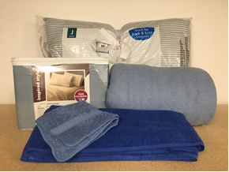

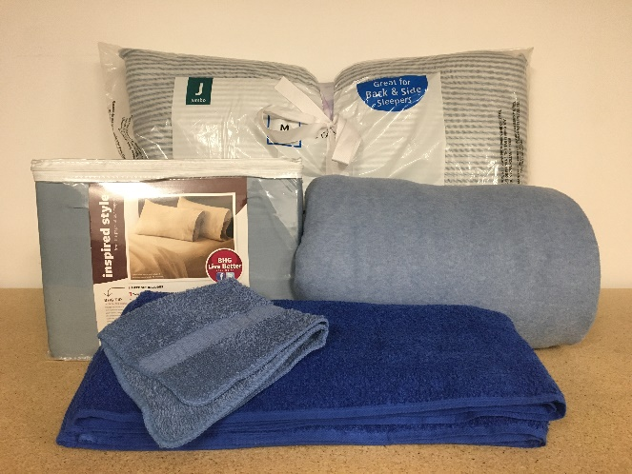

Nearby you can purchase:
- cleaning supplies
- desk lamp
- decorations
- trash can
- first aid kit
- flashlight
- food
- other items

community standards
As members of the Whatcom Community College community, all students have an obligation to demonstrate academic and personal honesty and integrity. Students are expected to respect individual rights, recognize their impact on others, and take responsibility for their actions. Students may be subject to disciplinary action for any activity that unreasonably disrupts the operations of the college or infringes on the rights of another member of the college community. Students are prohibited from engaging in any unlawful conduct and may be subject to criminal or civil prosecution.
The college may impose disciplinary sanctions against a student who commits, or aids, abets, incites, encourages, or assists another person to commit acts of misconduct, as defined by the Student Code of Conduct Policy WAC 132U-125.
As a member of the Residence Life community, each resident has the following rights and responsibilities that are intended to help students develop a healthy living community.

Rights and Responsibilities

Resident Rights
- Respect of self and personal belongings
- Freedom from excessive noise or disturbance during sleep and study
- A clean and safe environment
- Access to own bedroom and common areas of suite
- Fairness and due process for grievances
- Access to Residence Life staff for support

Resident Responsibilities
- Abide by the policies in this handbook and WCC’s Student Code of Conduct
- Respect the rights and needs of other residents
- Communicate needs with other residents and staff
- Support individual and campus community safety and security
- Always accept responsibility for behavior
- Maintain cleanliness and order of bedroom, bathroom, and common areas
- Honor agreed upon housing costs and fees
Residents are responsible for their own actions, the actions of their guests, and maintaining an environment that fosters academic success, safety, and the well-being of the community. When determined that a student has violated a policy, disciplinary actions may be implemented, including termination of your housing contract. Severe or continuous violations may be subject to progressive disciplinary action and/or criminal charges. Bellingham Police may be called for any crime, including violence and drug and alcohol violations.
The policies that follow provide a general outline of the types of conduct that are prohibited in Residence Life. They reflect local, state, and federal laws as well as unique requirements of a college residential environment. They are based on common sense and reflect the importance of consideration for other individuals and their property. These policies are not intended to define misconduct in complete terms.
Prohibited conduct includes:
- Damage or destruction of property
- Theft of property or services
- Harassment or intimidation, including bullying or stalking, whether in person or online
- Discrimination, including sexual or gender-based discrimination
- Hazing
- Endangerment, assault, or infliction of personal harm
- Sexual misconduct, including harassment, intimidation, and violence
- Obstruction or disruption of any college activity or property
- Failure to comply with college staff directives
- Use of weapons, firearms, explosives, dangerous devices, or chemicals
- Possession or use of alcohol or drugs, including marijuana, on campus and on Cedar Hall property
- Misuse of keys or unauthorized access to restricted areas
- Violations of any other college policy, rule, or procedure
- Forgery, alteration, or misuse of documents, funds, property, or electronic resources
- Any other action that interferes with the rights or safety of others

conduct process
Depending on the severity of the alleged policy violation, residents will meet with a designated Residence Life staff member or Conduct Officer. Your meeting notification letter will inform you with which staff member you will meet. During this meeting, staff will explain your rights and responsibilities, and talk with you about the alleged policy violation. Following the meeting, a decision will be made finding you “responsible” or “not responsible” for each policy violation and an outcome letter will be sent to you. The sanctions for any violations you are found responsible for and your right to appeal will be explained in your outcome letter.

Social media accounts are public platforms. Self-disclosure of a policy violation, including online, constitutes evidence of the violation. Whatcom can include a search of your social media accounts as part of an investigation. Do not make anything public that you would not want used for this purpose.
APPEALS
All appeals concerning Residence Life disciplinary actions must be submitted in writing to the Office of Student Conduct within 10 days of the receipt of the Conduct Officer’s decision. If no request for review is filed within 10 business days, the initial decision shall be deemed the final decision.
Orientation/floor meetings
Residence Life will hold a new resident orientation shortly after your move in. To remain eligible for the return of your refundable deposit, you must attend orientation. Residents must also attend all floor meetings to remain in good standing. Failure to attend floor meetings is a violation of your contract. If you are going to be absent from a floor meeting, please contact your Resident Advisor prior to the meeting.
Move in inspection
As part of the check-in process, residents, along with their Resident Advisor will complete a move in inspection of each bedroom and suite. Residents will be held responsible for any damages not listed on the inspection and may be charged fines as a result.
monthly inspections
To ensure the safety and cleanliness of Cedar Hall Residence Life staff will complete monthly inspections of each unit. Residents will receive at least 48 hours’ notice prior to inspections. You will be notified by staff if your room/suite did not pass inspection and any follow up action needed. Continued inspection violations may result in termination of your housing contract.
Renter’s Insurance
Residents are responsible for insuring their personal property. Whatcom assumes no responsibility for lost, damaged, or stolen items. Whatcom strongly recommends that you purchase a renter’s insurance policy through a licensed insurance provider.
taking care of your room
All rooms are furnished. Furnishings are the property of WCC, and misuse, theft, or destruction of college or student property is prohibited. Room size does not allow for any additional furniture. Each bedroom within a suite has an individual thermostat for temperature control. Suites are not equipped with air conditioning.

Decorations
Items that can cause damage to walls, doors or blinds are not permitted. This includes but is not limited to strip lights, darts, wallpaper, paint, tacks, nails, and strong adhesives. 3M hangers do not damage the walls and are permitted.

Prohibited decorations include: any posters or signs that are obviously intended to be pornographic, obscene, or offensive; decorative weaponry, and drug/alcohol advertisements.

Furniture
Suites are fully furnished. Residents are expected to return furniture to its original location upon move out. No furniture is to be removed from the suite. For your safety, do not stack furniture.

Bathroom
Be sure to keep your bathroom clean and dry to prevent mildew from occurring. Use your bathroom fan while showering. If mildew should develop, please let a staff person know.
Common Space in your suite
All residents are expected to keep the common areas of their suite clean and clutter free. When you are finished using an area, pick up after yourself by removing all garbage and cleaning the surface of the table/counter. Common areas include kitchen, bathrooms and living room.
kitchen
Please use caution when cooking in your suite. Always use your exhaust fan when cooking. If the smoke alarm goes off in your unit do not prop open the door to the hallway. This will activate the other alarms in the building. If a staff person does not immediately respond to the alarm call the duty phone at 360-201-1159. Staff needs to check to make sure there is not a fire before silencing the alarms. When possible, open the windows within your suite. If a grease fire occurs turn the stove off and cover the pot/skillet with a lid. Keep the lid on the pot until it has cooled. Do not try to put out a grease fire with water! Tampering with any smoke detector will result in the loss of your refundable deposit and may result in contract termination.
pest control
Pests such as bedbugs, fleas and ants can occur in communal living spaces. To avoid potential health issues, please remember to take out your trash regularly, do not leave food out on the counter and practice personal hygiene. If you find evidence of bed bugs, fleas, rodents, or other pests, inform Residence Life staff immediately. Do not spray bug or pest spray in your unit.

Living with Roommates
We encourage all residents to talk with their roommates about their living preferences within the first few days of living together. It is important to agree upon cleanliness, quiet time, and guests. RAs will discuss this process during the initial floor meeting/orientation and are available to help you with these discussions. Address your needs early to help prevent conflicts later. Here are some common roommate challenges:
- Use of common space (cleanliness, decorations, scheduling)
- Noise
- Guests, significant others
- Cultural differences, respect
- Sharing items (food, toiletries, dishes, etc.)

Conflict Resolution
Community will start to form on the day you arrive. You, your suitemates and all the residents and staff make up the Cedar Hall community. You will have the opportunity to meet people with a variety of backgrounds, cultures, and lifestyles. Your interactions with them will be some of the most interesting, and at times challenging, aspects of your college experience. In the event you find yourself in conflict with another resident, our Residence Life team has some suggestions:
- Attempt to understand others before starting to argue.
- Be direct and respectful in your interactions.
- Address your conflict with the person directly before approaching a staff member.
- If you cannot resolve the issue on your own, ask a Residence Life staff member for help.
CEDAR HALL POLICIES AND PROCEDURES:
Fire and Safety Equipment
Tampering with fire alarms or any other safety/security equipment is prohibited. A resident who tampers any safety equipment will forfeit their refundable deposit and may have their housing contract terminated. Do not touch or hang anything from any fire sprinkler as this can cause them to activate.
Restricted Areas
Residents are not permitted to enter storage or electrical closets, or rooftops under any condition. Residents may not enter staff offices or go behind the front desk unless accompanied by a staff member.
Smoking and vaping
The use of marijuana is prohibited anywhere on campus. Smoking and vaping are not permitted in Cedar Hall. Smoking/vaping must take place outside, at least 25 feet from any entrance to the building. This includes the use of cigarettes, electronic cigarettes, vaporizers, pipes, cigars, etc. If a resident violates this policy, they will be charged a $250 smoking fee and forfeit their refundable deposit. This may also result in immediate contract termination.
Solicitation
Due to a variety of local, state and college guidelines, students may not use their Cedar Hall residence for the purpose of running a business. Most forms of solicitation are prohibited in Cedar Hall and unauthorized solicitation should be immediately reported to staff. Prohibited forms of solicitation include contacting residents for the purpose of:
- Promoting an activity or event
- Promoting or endorsing an idea or person, such as a political candidate or religious belief
- Recruiting for a club or organization
- Selling something, such as an object, product or ticket to an activity or event, even for the purpose of fund-raising
Permitted forms of solicitation are made available to Cedar Hall staff to promote WCC related activities and programs. Whatcom Community College students, organizations and clubs who would like permission to post notices/information should contact Cedar Hall staff at residencelife@whatcom.edu
Storage
No storage space is provided outside of each resident’s personal room. Units and bedrooms are furnished, and furniture must remain in the unit. Any personal belongings left in common areas, including hallways and lounges, may be discarded.
drugs and alcohol
Drugs and alcohol are not permitted in Cedar Hall, regardless of whether the resident or guest is of legal age. No person shall possess, use, consume, sell, manufacture, cultivate, package, or distribute a controlled or illegal drug or substance, including marijuana, in Cedar Hall or on college property. While state law permits the recreational use of marijuana, federal law prohibits such use on college property or in connection with college activities.

weapons
All weapons are prohibited in Cedar Hall and on campus. Possession, holding, wearing, transporting, storage or presence of any firearm, dagger, sword, knife or other cutting or stabbing instrument, club, explosive device, or any other weapon apparently capable of producing bodily harm is prohibited on the college campus, subject to the following exceptions: a) Commissioned law enforcement personnel or legally authorized military personnel while in performance of their duties; b) A student with a valid concealed weapons permit may store a weapon in their vehicle parked on campus in accordance with RCW 9.41.050(2) or (3), provided the vehicle is locked and the weapon is concealed from view; or c) The president may grant permission to bring a weapon on campus upon a determination that the weapon is reasonably related to a legitimate pedagogical purpose. Such permission shall be in writing and shall be subject to such terms or conditions incorporated in the written permission.
This policy is applicable to all residents, students, faculty, staff, and visitors.
whatcom campus alerts
Students, faculty, and staff are highly encouraged to sign up to receive Whatcom Alert messages to your personal email account and personal cell phone number in case of an emergency. Login and update your information here.
Whatcom Safety and Security will notify the campus community in times of emergency via the Whatcom Alert system. This system includes the following communication outlets: Text, email, computer desktop alerts, building annunciation through phones and speakers, public website (whatcom.edu) and social media. Please note: Do not reply to Whatcom Alert emails or text messages. Please wait for additional information to be sent. If you experience or witness an emergency call 9-1-1 immediately.

Payments
Housing fees are billed for the academic quarter and added to your student account after move-in and due within 10 days after the start of the quarter. Initial housing charges will also include a $250 non-refundable cleaning fee and a $250 refundable deposit. Any unpaid housing fees may result in a block on your account and/or contract termination.
Consolidation
Residence Life reserves the right to move students to complete necessary maintenance or maximize the efficiency and safety of Cedar Hall. Residents will be provided as much notice as possible if they need to move units for any reason.
Cohabitation
Residents may not sublet their room or allow another person to reside with them. Those found residing in student housing without a contract will be immediately asked to leave and their host resident will be subject to the conduct process and additional fees.
room change policy
Room transfers are at the discretion of the Residence Life Staff. Room transfers are not available during the first 2 weeks of the quarter. Transfer requests should be e-mailed to residencelife@whatcom.edu describing the reason for your request. The Residence Life Staff will attempt to accommodate individual requests but cannot guarantee them. If your request is approved, you will be charged a $100 transfer fee to cover the cleaning of the room from which you are moving.

Room Takeover
There will be times when a room in the suite is unoccupied. Residents may not enter or store their belongings in any vacant room. Any resident who has used a vacant space will be charged a cleaning fee and fees for any damage incurred from use of the space.
key policy
Your WCC student ID is programmed to provide access to Cedar Hall and your suite. Residents will also be provided a bedroom key at check-in. ID cards and keys are the sole responsibility of the resident. Keys and ID cards are not to be loaned, copied, or left unattended. Allowing non-residents to use resident keys or ID cards is considered a serious violation that jeopardizes the safety and security of the community and may result in the termination of your housing contract.
Lock-Outs
If you are locked out of your room during business hours, ask the front desk for assistance. After hours, call the Residence Life on-call phone at 360-201-1159. Residents are provided three free lock outs per quarter and charged $25 per lock out after the third occurrence.

Lost/Stolen Keys
To maintain safety and security in Cedar Hall, notify Residence Life staff immediately if you lose your student ID card or bedroom key. Resident will be charged for a replacement key/student ID and if necessary, for rekeying locks.
Quiet Hours
Quiet hours are in effect daily from 10pm-8am. Loud noises heard through a closed door will be considered excessive and in violation of quiet hours. Outside of quiet hours, we ask that residents maintain a courteous atmosphere for those who choose to study or sleep during the day. Televisions, gaming systems, and music should not be played at an excessive volume.
Guests
Guests must sign in and out at the front desk and always remain with the resident hosting them while in the building. Residents are held responsible for the behavior of their guests. Guests should have no known criminal background. Previous residents who have been evicted from Residence Life are not allowed as guests. Any guest violating the Residence Life contract will be asked to leave immediately.

Overnight guests are limited to two consecutive nights and 7 nights per quarter. Guests are permitted to sleep in the resident’s room only. Other rooms in the unit are not to be entered. Any resident allowing guests to stay in a vacant room will be charged additional housing and cleaning fees. To request an exception to the guest policy, contact Residence Life staff: residencelife@whatcom.edu.

Pets
Pets are not allowed in Cedar Hall. Violations to the pet policy may result in termination of your housing contract and forfeiture of your security deposit.
break periods
Cedar Hall offers housing all year including the break between quarters. Residents are permitted to remain in Cedar Hall during breaks and summer if they are enrolled for the following quarter. If residents are moving out at the end of a quarter, they must move out within 3 days after the quarter ends.

services & amenities
Front Desk
The front desk in Cedar Hall serves as a central location of information and services for residents. Front desk services include:

- Mail and package pickup
- Access to the building or your unit/bedroom if you lock yourself out-each student is allowed three free lock outs per quarter. A $25 fee will be added to your student account for any additional lock outs requiring staff assistance
- Assistance with requesting maintenance in your suite
- Assistance filling out any forms in erezlife or accessing your student account
- Checking out games or equipment
- Lost and found
- Emergency assistance
- General questions

Mail and packages
Mail and packages shipped through the U.S. Postal Service will be delivered to Cedar Hall Monday through Friday. The front desk also accepts packages or items shipped via other delivery services. In following with privacy regulations, staff will not confirm or deny whether a student lives in the building before accepting a package. Packages that are hazardous or violate College policy will not be accepted.
Residents will receive an e-mail when a package has arrived for them. Please bring your student ID to the front desk when picking up your package. The package must be picked up by the resident it is addressed to. If the item remains in the mail room for more than a week, or if we are unable to identify the recipient, the package will be returned to sender. Whatcom shall not be held liable for theft or damage to any item.
Residents are responsible for checking in with the front desk for standard mail. There is a basket at the front desk for outgoing mail. Packages cannot be sent from Cedar Hall. Please visit your local post office, UPS, or shipping store to mail a package.
Your mailing address is:
204 Olivine Lane Unit # XXX
Bellingham, WA 98226

Network Services
Each suite is equipped with a Smart TV and Wi-Fi is available throughout the building. To access the Wi-Fi information for Cedar Hall, log in to your ctclink. The community televisions in the common areas are equipped with cable.

Common Areas
Please remember that common areas are used by all residents. Please keep these areas clean so that all members of the community can enjoy the spaces. Do not dispose of your personal trash in any common area. Please observe the open hours for these spaces and realize the impact that noise has on the nearby suites. Program equipment is available for check out at the front desk during desk hours. Residence Life staff can answer any questions regarding the use of any common spaces in Cedar Hall.

study areas
Study spaces are available for a group to reserve and when not reserved can be used by any resident(s) of Cedar Hall.

community kitchen
The community kitchen is open to all residents of Cedar Hall and can be reserved for a special event/program. The items in the kitchen are property of Residence Life and must remain in the kitchen. Residents are expected to clean up after themselves when using the community kitchen.

4th floor lounge
The fourth-floor lounge has a smart TV/cable for gaming and gathering, a small kitchen and comfortable seating.

Laundry
The laundry room is located on the first floor of Cedar Hall. Laundry is paid for using your student ID card. Funds can be added to your ID card through ctclink. Residents are responsible for emptying the washers and dryers and removing lint from the dryer lint trap after each use. Non-residents are prohibited from using the laundry facilities. Whatcom does not assume responsibility for loss or damage to any laundry or supplies left unattended in the laundry room. If a machine is not working properly, please inform staff. Clothes found in or on top of washer/dryers over a 24-hour period will be removed and placed in lost and found.

Parking/Transportation
There is limited resident parking in the back parking lot of Cedar Hall available on a first come first serve basis. Residents and/or their guests are not permitted to park in the restricted front parking lot of Cedar Hall. Additional parking is available on campus in the orange lot across Cordata. All resident vehicles are required to display a parking permit while parked at Cedar Hall or on campus. Parking is free and permits are issued to residents upon move in. Guests must park in the orange lot across Cordata. Guest parking passes are available at the front desk and should be displayed on the guest’s dashboard. Read more about parking at Whatcom.
Bus service is available from Cordata Station, located next to Cedar Hall. Your student ID card works as a bus pass if you are enrolled in classes and have paid tuition.

Bicycles
Bicycles must be stored in one of the designated Cedar Hall bike storage areas. Due to bicycle theft, residents are encouraged to keep their bicycles in the indoor bike storage. Whatcom does not assume responsibility for theft or damage to bicycles or any other student property. The use of bicycles or other wheeled vehicles is prohibited inside the buildings. Please register your bicycle with Residence Life staff for access to the bike room storage.

Dining
There are no dining services at Cedar Hall. The Cove is open in the Learning Commons and there are many restaurants close by.

Waste Disposal
Each resident is responsible for disposing of their own trash and recycling. All trash should be bagged and placed in the trash receptacle located on the first floor of Cedar Hall. Please make sure that your trash/recycle bag is not leaking when you transport it to the trash room.
Recycled items must be clean and placed in the appropriate bin. Please do not place plastic garbage bags in recycle bins or SSC services will not pick up the recycle. Residence Life has compost bins for those that choose to compost food.

access and disability accommodations
Cedar Hall has several accessible units available for residents that use a wheelchair or have other accessibility needs. Accessible parking spots are available for drivers displaying a valid state-issued permit. If you have a valid permit and a parking spot is not available, you may park in the front parking lot of Cedar Hall. Anyone violating the parking policy will be ticketed and/or towed.
Residence Life allows emotional support animals (ESAs) in housing for a documented mental health issue, once approved through Access and Disability Services. ESAs are not permitted in common areas or elsewhere on campus and must remain in the resident’s room or suite. Resident must complete an ESA application and procedure agreement and is responsible for adhering to all requirements including cleaning up after and properly disposing of their animal’s waste.
To apply for approval for an ESA, or to request other accommodations, please contact Access and Disability Services ; ADS@whatcom.edu or 360-383-3080.

Maintenance Services
Routine Maintenance
For any non-emergency maintenance issue within your unit, please submit a maintenance request through erezlife using the steps below. A Residence Life staff person will contact you to check on the issue and submit a request to WCC facilities and maintenance department when necessary. For non-emergent issues, you will receive at least 24 hours prior to maintenance coming into your unit. Maintenance will leave a door hanger on your door noting the work completed and inform you of any follow up needed. Maintenance requests are usually addressed within 48 hours. Completion may take longer if parts/replacement is necessary. To fill out a maintenance request:
- Go to whatcom.erezlife.com
- Sign in, and (if you are on a phone) click on the upper left button to open the menu.

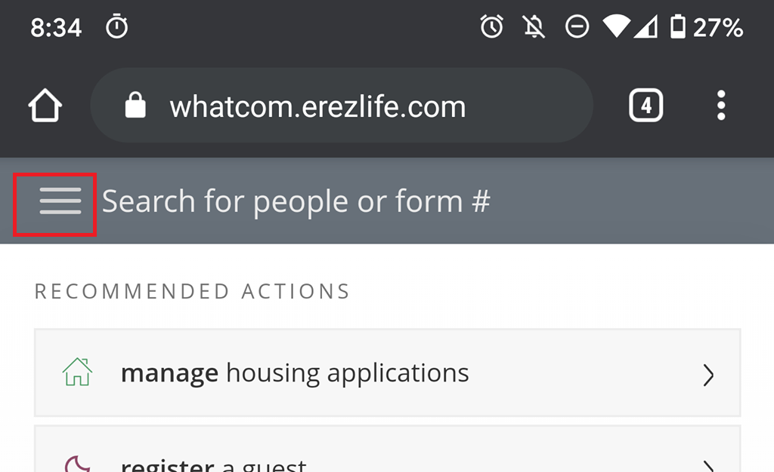

- Click on the Forms tab, and then “Maintenance Request”
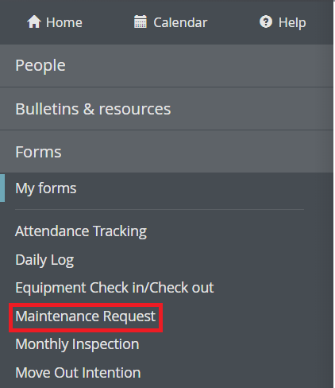

- Fill out the date and residence, make sure to be as specific as possible with the location.

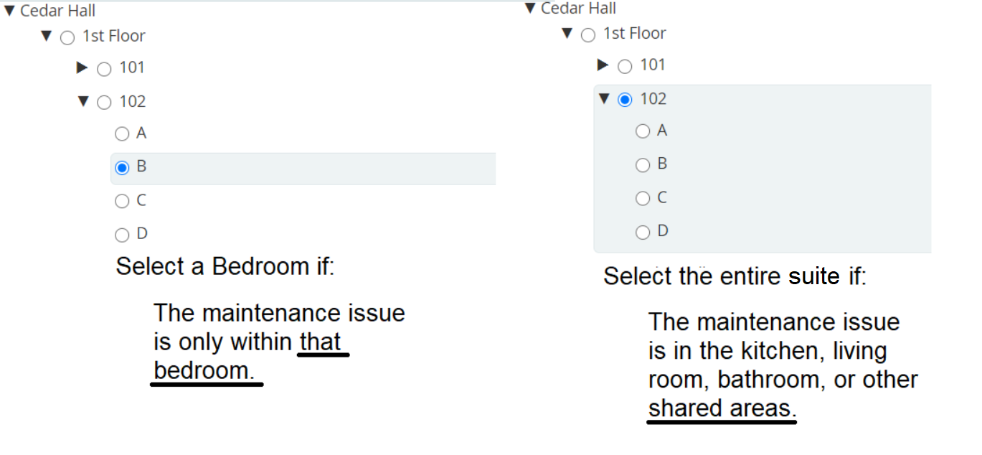

- Then fill out the lower section and try to be as specific as possible.

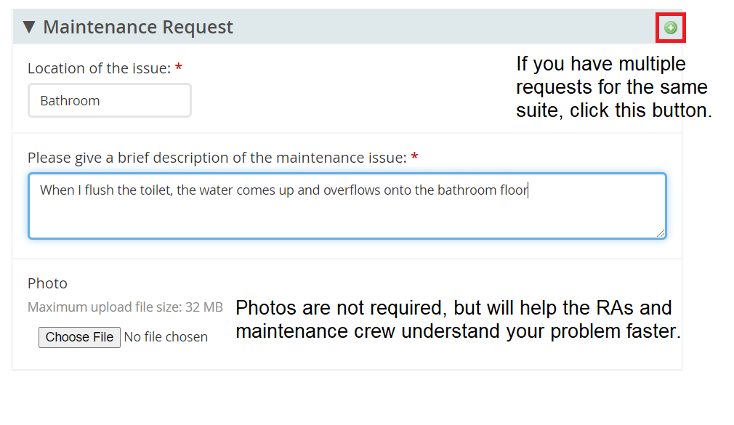
- Then, click on “Review” to send the maintenance request to your RAs.

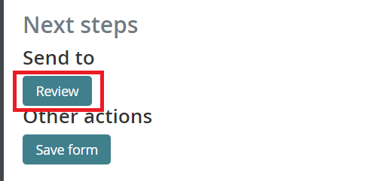
Emergency Maintenance
For emergency maintenance issues, contact a staff person right away. If after hours, call the duty phone immediately at 360-201-1159. The following maintenance issues are emergencies:
- Plumbing (toilet is not flushing or is spewing water)
- Broken window
- Fire safety equipment issue (fire alarm is activated or beeping)
- Loss of heat or hot water
- Power outage
- Key/lock issues (cannot unlock or lock your door)
- Any situation that compromises the health or safety of the residents/community

Safety

release of information
The Family Educational Rights and Privacy Act (FERPA) protects the privacy of students. Once a housing application has been received staff will not share personal housing information with anyone other than the student unless the student has submitted a release of information in erezlife.

personal safety
The mission of the Whatcom Community College Campus Safety and Security is to provide and maintain a safe and welcoming environment for students, faculty, staff, and visitors. This is accomplished by maintaining a community-friendly approach that recognizes the value of a diverse community.
Campus Safety and Security works together with all members of the Campus Community to preserve life, protect property, investigate crime, promote individual responsibility, and fulfill community commitments.
Campus Safety and Security works closely with Residence Life staff to ensure the safety and security of all residents and visitors to Cedar Hall. Residence Life staff are on call 24 hours a day to respond to emergencies and crisis situations. WCC partners with the City of Bellingham’s Police and Fire Departments for emergency services.
Cedar Hall residents have a vital role in maintaining a safe campus community by taking personal responsibility for their own conduct and conduct of their guests.
Campus Safety and Security provides security services for all students, faculty, staff, and visitors at WCC. Safety is the top priority. Please contact your Resident Advisor for a list of security services available.

How to Report a Crime
If you observe a crime in progress, immediately CALL 9-1-1. Do not approach the situation. Be prepared to provide a description of the situation, of the person(s) involved, and where the crime is occurring. Stay at a safe distance! If this is a crime occurring in or around Cedar Hall; and / or involving a fellow Cedar Hall resident, please contact a Residence Life staff person as soon as it is safe to do so.
If you have been a victim of a crime; know of a crime that has occurred or are concerned for your personal safety, CALL 9-1-1. If there is not an immediate threat, contact a Residence Life staff person as soon as possible. They are trained to provide guidance and support in matters of urgency.
If you believe you have been the target of a hate crime or bias incident, please inform a staff member immediately. If you have this experience off-campus unrelated to the WCC campus community, you are encouraged to CALL 9-1-1 immediately.

Missing person
Any person concerned that a resident might be missing is required to notify a Residence Life staff person. A resident may be considered missing when the student has been absent from the Residence Hall for 24 hours or longer without giving notice of absence. The college will follow the institution’s missing student policy which may include contacting the parent of a student of any age, whether the parent is listed as an emergency contact.

resident Welfare Check
When a parent or friend inquires about a student who has been unreachable, Residence Life staff may perform a courtesy visit to the suite. If the resident is located, they will be encouraged to contact the individual trying to reach them. Due to federal privacy laws, we will not be able to confirm with parents, friends, or other individuals that the resident has been located. College staff may enter a room if there is legitimate concern about the immediate health or safety of a student.

Medical Emergencies
If you or someone you know is experiencing a medical emergency that requires immediate medical attention, CALL 9-1-1 Inform a Residence Life staff member right away or ask someone to contact them for you. When calling 9-1-1 be prepared to give the emergency dispatcher as much information as possible, including your address and a description of the emergency. Staff are not permitted to transport residents to the hospital.

SAFE PRACTICES
WCC is a beautiful campus with lush landscape, and friendly wildlife. Due to this inviting campus atmosphere, WCC experiences visits from neighbors and members of the greater community.
Although WCC is in a safe community, crimes can occur. Most incidents are crimes of opportunity due to an unlocked vehicle or an unattended bag. To lessen these opportunities and to help prevent theft, lock your car door, remember to keep your suite doors closed and locked; shut windows when leaving; and secure all valuables by storing them out of view and never leaving them unattended when in common or shared spaces outside your suite. Remember to close your window blinds to maintain privacy.
Avoid walking or running alone at night. Be mindful of the area and others around you and remember to stay on well-lit paths when traveling at night.
Do not loan your keycard or keys to anyone and NEVER prop open any exterior doors at Cedar Hall. When entering the building, do not allow anyone you do not know to follow you in or enter the building as you leave. If someone does, notify a Residence Life staff member immediately. Before you leave Cedar Hall, look outside, and report any concerning persons before exiting the building.
While inside or outside Cedar Hall, if you are approached by someone or observe behavior by someone that makes you feel unsafe, trust your instincts, and walk away. Inform a staff person immediately and / or CALL 9-1-1.
In all matters of concerning behavior or criminal activity, you are encouraged to submit a WCC Incident Report. A staff person can help you with this process.

LARGE-SCALE emergency EVENTS

Fire
In the case of a fire:
- Remain calm. Call 9-1-1
- If it is safe to do so, exit the building immediately. Do not re-enter a burning building to retrieve possessions. If fire or smoke is visible, stay low to the ground and exit away from the fire.
- As you exit, attempt to warn others.
- Gather behind the storage shed behind Cedar Hall
- If your suite door is hot to the touch, do not exit. Open your window, stuff towels under door, and wait for emergency responders to reach you.

The designated evacuation location is behind the picnic shelter in the back of Cedar Hall. Please follow staff direction when you reach the area.

Earthquake
During the Quake:
- Remain calm. Do not panic or run.
- Stay where you are – indoors, outdoors, or in a car.
- If indoors, immediately drop, cover, and hold-on. Drop low to the ground, get under a heavy table or desk or against an inside corner wall away from windows, mirrors, or heavy objects. Cover your head. Watch for objects that could fall on you such as light fixtures, books, furniture, or bricks.
- Wait until the shaking stops before moving.
- Once shaking stops, immediately exit the building. Do NOT use elevators. Get a safe distance away from the building. If you are unable to use the stairs, wait in the emergency refuge area located near the elevator and ask someone to inform emergency personnel. If you are in a wheelchair, position yourself against the wall and lock your brakes. If an aftershock occurs, cover your head. Emergency personnel will come to you as soon as possible. There is an Evacu-Chair located on the fourth floor. This device may be used to safely carry one person at a time down the stairs.
- If outdoors, avoid tall buildings, trees, power lines and other objects that could fall. Move to an open area if possible. Drop to the ground and cover your head. Wait for the shaking to stop.

After the Quake:
- Check yourself first. You may be injured without realizing it.
- Think before you move. Use common sense and do not take any risks out of panic.
- Be prepared for aftershocks. Wait until all motion has stopped before cautiously exiting.
- Do not light a match or turn on a light switch. At night, use a flashlight.
After the quake, walk to the Cedar Hall field. Attempt to group together with others from your floor. This will assist in accounting for all students in a timely manner and identifying any potentially missing students or staff. You will receive further directions and information from staff at that location.

Lockdown
A lockdown is a security measure taken during an emergency to prevent people from leaving or entering a building. In the event of a lockdown at Cedar Hall:
Cedar Hall residents, staff and visitors should:
- If in your suite, stay where you are, lock your door.
- If you are in the open common area, get to a room and secure yourself by locking the door or by barricading the door.
- If you are outside the building, leave the area and seek a safe location away from campus. Notify your Resident Advisor of your location as soon as safely able to do so.
- Remain calm and quiet.
- Stay away from windows and doors.
- Do not open doors for any reason.
- Close window blinds.
- Turn off lights, computer monitors, and music.
- Turn cell phones to vibrate and refrain from using them except for emergency notification. Think safety first and refrain from filming live social media broadcasts.
- Assist persons with disabilities or injuries who may be in need.
Remain in place, even if a fire alarm has been activated, unless:
- An “all clear” message has been delivered through the College’s Emergency Notification System or by emergency personnel
- You are in immediate danger
- You are instructed to leave by a uniformed emergency personnel (police, fire, campus safety and security, etc.)
- Do not attempt to restrain any person who demands to leave a locked down space.

Severe Weather/power Outage
In the event of a power outage, residents should remain calm and locate a flashlight or use the flashlight on their phone. If you are in an unlit area, proceed cautiously to an area with emergency lighting and remain in that area until you hear from a Residence Life staff member.
Residents in an elevator should remain calm and use the emergency call button or telephone to alert Residence Life staff or Campus Safety & Security. In the event of a significant power outage, the front desk will serve as the central communication center for residents until power is restored.
For your safety, do not exit the building during high winds. Live electrical wires, debris and falling trees may create a danger.

EMERGENCY DRILLS
All residents shall be prepared to participate in all fire evacuation drills (mandatory) and other emergency drills conducted in Cedar Hall.

difficult situations of concern
In college, you will experience situations that you are unsure how to respond to. These situations may appear innocent or “typical” but can be serious and/or life-threatening if not addressed. If you believe someone is experiencing such a crisis, please contact a staff person immediately. Do not worry about getting in trouble or the person becoming angry or embarrassed—remember, you cared enough to help. It is always best to be prepared with a plan before finding yourself in a crisis. That is why we have provided an overview of some challenges faced by college students.

Drug or Alcohol Overdose
Critical signs and symptoms of an overdose
- Mental confusion, stupor, coma, or person is unresponsive
- Vomiting, especially while unconscious
- Seizures
- Slow or irregular breathing
- Hypothermia (low body temperature), bluish skin color, paleness
What should you do if you suspect someone has overdosed?
- Know the above symptoms.
- Do not wait for all symptoms to be present.
- Be aware that a person who has passed out may die.
- Do not try to guess whether medical care is needed.
- If there is any suspicion of an overdose, call 9-1-1 immediately and inform a Residence Life staff member.
What can happen to someone during an overdose if they do not receive assistance?
- Victim can choke on his or her own vomit. To prevent this, roll the victim to their side and wait for help to arrive.
- Breathing slows, becomes irregular, or stops.
- Heart beats irregularly or stops.
- Hypothermia (low body temperature).
- Hypoglycemia (too little blood sugar) leads to seizures.
- Severe dehydration from vomiting can cause seizures, permanent brain damage, or death.

Even if the victim lives, an overdose can lead to irreversible brain damage. Rapid binge drinking (which often happens during drinking games, on a bet, or a dare) is especially dangerous because the victim can ingest a fatal dose before becoming unconscious.

Sexual Assault
1 in 10 college students experiences a rape or sexual assault while pursuing their degree. While this statistic is shocking, we can all help to lower it by responding appropriately to consent or lack of consent and taking care of each other in times of crisis.
What is consent?
When someone gives consent, they are giving permission for something to happen or agreeing to do something. This means they need to know exactly what they are agreeing to so be clear in your request.
- Always ask for consent before you begin sexual activity, including kissing, cuddling or any sexual activity, even if the person has consented in the past.
- Your partner might not give you a clear “no” if they are not interested but that does not mean they are saying “yes.” “um…I guess,” is an indication they do not really want to do what you are asking them to.
- Pay attention to your partner’s body language. If they pull away, tense up or look uncomfortable you should check in. For example, “You do not seem to be into this. Do you want to stop?”
- Sometimes your partner will say “No” to engaging in sexual activity. Reassure them that you are glad they can be honest with you and respond appropriately, “That is OK. Maybe another time.”
- Consent matters. Talking about what your partner wants to do ensures that sex is consensual and makes it more enjoyable. Your partner will feel more comfortable being close to you.

So, you know how to practice consent, but how do you go about caring for someone if they have experienced sexual assault?
Critical Signs and Symptoms of Sexual Assault
- Shock, guilt, confusion, anger, fear, helplessness, and depression are common responses to sexual assault. These are your cues to check in on your friend and ask them if they are okay and offer to listen.
- A student may have difficulty concentrating on schoolwork. She/he may withdraw from class discussion and interaction with peers or may cease coming to class entirely.
- Students may experience flashbacks, especially when unpredictable triggering events happen in the world around them.
- Weight loss, poor hygiene, sleeplessness, jumpiness, paranoia, and not wanting to be touched can all be signs of sexual assault.
What should you do if you suspect someone has been sexually assaulted?
- Offer support. Offer to call someone they trust or reach out to a confidential resource. Do not ask too many, or detailed questions, just listen to them. You do not need to know the details, your focus in on supporting the person. Do not blame the victim (e.g., he/she/they was asking to be raped if he/she/they wore clothes, went to the perpetrator's room, was drinking, walked home alone).
- Offer to help the victim in getting medical help. Even if they feel fine, injuries can appear long after the incident. Remember, it is not your place to force the person to get medical help, just make sure they know that you support them in seeking help if they want to.
- Tell someone. Encourage the person to report the incident to a WCC staff member. This helps the college respond appropriately and ensures a safe living and learning environment for everyone. There is no time limit for reporting an incident to the College. Reporting can be confidential and does not have to result in a police report.
- Preserve evidence. Police and nurse examiners are in the best position to secure evidence of a crime. If the victim wants to seek medical support, they can assist in collecting physical evidence, ideally within the first 24 hours. The victim can preserve evidence by refraining from: taking a shower, brushing teeth, eating, or drinking. If they change clothes, keep those clothes in a paper bag.
- See Something? Say Something. Pay attention to cues, comments, instincts, and experiences.
- Listen. Do not attempt to “take control,” since the victim already feels a loss of control.
- Control your own feelings. The victim is allowed to feel however they feel in the moment, and the best thing you can do is stay calm.
What can happen to someone who has experienced an assault that goes unaddressed?
- Injuries, such as internal bleeding
- Pregnancy
- Sexually transmitted viruses
- Self-harm/suicidal thoughts or actions
- Repeated assault or other violence
- Depression, anxiety, PTSD

Title IX
Title IX is federal law that prohibits discrimination based on sex. Sex discrimination includes all forms of sexual misconduct (such as sexual harassment, sexual assault, rape, and stalking). Title IX also prohibits discrimination based on a person's LGBTQIA + identity, pregnancy or parenting status, or marital status. Washington State prohibits discrimination against those that identify as Transgender or non-binary.
What is Sexual Harassment?
Sexual harassment is a form of discrimination consisting of unwelcome, gender-based verbal, written, electronic, and/or physical conduct. Sexual harassment does not have to be of a sexual nature, however, and can include offensive remarks about a person’s gender.
Examples that may qualify as sexual harassment include:
- Persistent comments or questions of a sexual nature
- An instructor who promises a student a better grade in exchange for sexual favors
- Unwelcome touching, patting, hugging, kissing, or brushing against an individual’s body
- Unwelcome letters, e-mails, texts, telephone calls or other communications referring to sexual activities
What is Sexual Violence?
Sexual Violence is a type of sexual discrimination and harassment. All the below are types of sexual violence:
- Nonconsensual sexual intercourse-any intercourse with any object, by a person upon another person, which is not consensual
- Nonconsensual sexual contact-any intentional sexual touching, however slight, by a person, upon another person, which is not consensual
- Domestic violence-Asserted violence by the victim’s current or former spouse, domestic partner, or family member
- Dating violence-Violence by a person who has been in a romantic or intimate relationship with the victim
- Stalking-intentional and repeated harassment or following of another person, which places the person in reasonable fear that the perpetrator intends to injure, intimidate, or harass the person
How to Report Sexual Misconduct at Whatcom
Our Title IX Coordinator has oversight for the College's compliance with Title IX. This person’s job is to receive and assess all reports from the entire college, and make sure people are connected to the resources they need. They can also answer any questions you may have about sexual misconduct, sexual assault, or gender-based violence. Any incidents or questions should be directed to Becky Rawlings in Human Resources. 360-383-3404 or brawlings@whatcom.edu
All faculty and staff at Whatcom are mandated to report knowledge of Title IX incidents to the WCC Title IX Coordinator. Please report any concerns to a Residence Life staff member or the Title IX Coordinator.
Support
Students may receive professional, confidential no-cost crisis counseling services at the Counseling Center, located in Laidlaw 116. The phone number is 360.383.3080 and email is counseling@whatcom.edu
Campus Safety & Security provides free after-hours escort services. Call 360.715.2418 if you feel unsafe walking to your car or around campus by yourself.
Extreme Mental or Emotional Distress
SUICIDAL THOUGHTS OR ACTIONS
Critical signs and symptoms of suicidality
- Talking about wanting to die or kill oneself
- Talking about feeling hopeless or having no purpose
- Talking about feeling trapped or being in unbearable pain
- Talking about being a burden to others
- Increasing use of alcohol or drugs
- Acting anxious, agitated, or reckless
- Sleeping too little or too much
- Withdrawing or feeling isolated
- Showing rage or talking about seeking revenge
- Displaying extreme mood swings
What should you do if you suspect someone is suicidal?
- Do not leave the person alone. Call for help from a Residence Life staff member. Staff can assist in getting the person the resources they need.
- Listen. Do not debate or minimize their feelings.
- Remain calm. A person in crisis is not likely to be dangerous, although they may trigger your fear response.
What can happen to someone in extreme distress that goes unaddressed?
- Self-harm/harm to others
- Escalation of symptoms or dangerous behaviors
- Inability to focus on studies and be successful in school

POLICIES AND PROCEDURES:

Moving out
Responsibility
Resident must follow proper check out procedures. If resident fails to follow proper procedures, informing a Resident Life staff member of your departure, having your room inspected, your ID access disabled and returning your bedroom key, a $300 fine will be added to the resident’s student account. Whatcom is not responsible for any items left behind in a resident’s room/suite. Any items left behind will be discarded at the resident’s expense.
move out cleaning
The following is an outline of items checked at move out. To avoid cleaning charges more than your cleaning fee, please make sure that this list is completed prior to your move out inspection. Cleaning supplies are available for check out at the front desk.

Bedrooms
- Remove all personal items, remember to check all drawers
- Move all furniture to original location
- Sweep and mop floors

Door and Walls
- Remove all picture tacks, adhesive, hangers, handprints, smudges, soil, and scrape marks from the walls

Trash
- Remove all personal items/trash/recycle from the unit. Anything left behind will be discarded and a disposal fee will be added to your student account

Bathroom
- Remove all personal items
- Clean toilet, sink and counter
- Sweep and mop floor

Kitchen
- Remove your food from refrigerator, freezer, and cabinets
- Clean microwave
- Wipe down stove top using soft sponge and degreaser (do not scratch)
- Wipe the wall behind stove
- Sweep and mop the floor

Living Room
- Move furniture back to its original location
- Sweep and mop the floor

Damages
Residence Life staff will enter a vacated unit to assess or conduct repairs. Costs for damage repair in the common area will be split between residents unless it is proven the damage was a result of one resident. Damages confined to a bedroom will be charged to the resident of that room.

Common charges include:
- Wall damage from unapproved fasteners or moving furniture
- Personal items/trash left behind
- Damaged Furniture
- Cleaning costs that exceed the $250 cleaning fee

A resident is eligible to receive their $250 deposit back providing:
- Resident provided 30-day notice to vacate
- Resident attended new resident orientation
- The unit is left clean
- No items were left behind
- No damage to the unit
- No outstanding housing fees are owed to the college

Refund of deposit can take 10-14 business days. Additional time may be needed to process checks. Checks will be mailed to whatever address is on file. Please be sure to update your address with WCC.

