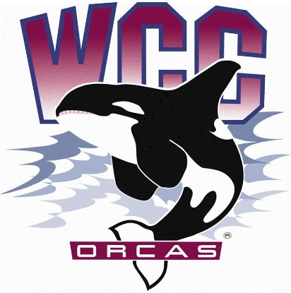
ASWCC Executive Board Meeting Minutes
Date: January 22nd, 2024
Location: Syre 108

- Alaina Hirsch – ASWCC President, chair
Voting members
- Krystan Andreason – ASWCC VP for Campus Advocacy
- Matthew Valencia – ASWCC VP for Clubs
- Bella Nguyen – ASWCC VP for Operations, minutes taker
Meeting called to order at 3:04 pm
Welcome, Land Acknowledgement and Pronoun Statement
Approval of meeting minutes
- Suggestion to attach the governance committee reports in the meeting minutes
- Unanimous vote to table the meeting minutes
Engagement
Governance Committee reports
- SEM committee – Hang Pham (next meeting)
Coffee with a Student Leader event
- Legislative Advocacy Survey – went over the legislative questions to ask students according to the WACTCSA (Washing Community & Technical College Student Association) legislative agenda
- Which legislative issue is the most important to you? Housing affordability, textbook affordability, harm reduction, student pay equity and increase financial assistance
- How much did you spend on textbook this quarter?
- Have you personally had trouble in finding affordable housing while being a student? If yes, please describe
- If you received financial aid, is it enough to cover your tuition and textbook?
- Legislative Advocacy Day preparation
Club Report
- 5 active clubs
- Japanese Club
- Badminton Club
- Volleyball Club
- Campus Christian Fellowship (CCF) Club
- Sustainable Oriented Students (SOS) Club
- Winter Club Fair the following day, 1/23 from 1-4 pm in Syre Auditorium. There will be clubs, ASWCC Student Unions, caricature, food,…
- Due to campus closure, there will be no InterClub Council for January, and the next ICC is going to be on 2/15 from 9:30 – 10:30 am in Syre 216
Advocacy
Social Justice Committee Report
- Reminder about the next meeting on 1/30 at 9:30 am in Syre 216
- The committee members have been having discussion about Safe Zone project, space planning request for gender inclusive bathrooms, lockers, and planning for the Students Leading Change Conference
Health & Wellness Committee Report
- Reminder about the next meeting the following day, 1/23 at 9:30 am in Syre 216
- Updates on the Interdivisional Food Fight Challenge
- Administrative is in the lead by 1/9 with 457.5lbs of food
- The total number of the Food Fight until 1/12 was 1048.4lbs of food
- Discussed gaining the allowed use of a specific translation app to accommodate more to students, QR code that leads to counselling page and the expansion of the resources brochure to include on campus resources
- Cookies, Condoms and Consent is in planning, with the lead of a member in the Student Life and Engagement Team
- There will be a Dodging Hunger during half time of the basketball games on 1/27, and the winner for the Food Fight challenge will also be announced
- For Fall quarter Finals Week, 158 students came for support
President’s Report
- Working on finding a suitable pool table and if there is still money to spare, a plaque will be considered
- On 2/13, the Syre Auditorium is booked for Mario Kart event, but now it is asked to be moved in order to have the forum for the Vice President of Instruction. On 2/15, Campus Christian Fellowship Club has booked to use Syre 108, but has also been asked to move due to International Week
Ad hoc Space Planning Committee
- Wanted to have this committee on board in order to finalize decision regarding space planning request like the gaming spot, larger request that may expand the working spaces of ASWCC Student Leader, arts,… The lead and members for this committee can be anyone volunteer
Selection Committee Update
- Had an group interview for the open Executive Board position
- The interviews and results are being reviewed so application will be closed
S&A Fee Committee Update
- Had the first meeting with the number of 10 attendees
- Went over basic training about policies and uses of S&A Fee
- The next meeting will be on 2/1 at 1:30 – 2:30 pm in Syre 216
Legacy
Bylaws Review Committee Report
- The committee is meeting every Wednesday from 4 – 5 pm in Syre 216, by far there has been 1 meeting on 1/10
- Has been going through Bylaws Draft that the Senate approved from last year, all amendments and suggestions are considered by the committee member
- Hope to finish a new draft by 2/23, and from that take it to the Board of Trustees for final approval
Advisory Report
- There is going to be delay in updating and finalizing the ASWCC Hub mobile app due to the shortage of professional staff. A good solution is to have an Ad hoc committee that can oversee the app
- Hoping to have next year selection application out during this academic year so that the Selection committee can have more time to go over application
Open floor for comments from the gallery
- Suggestion to keep the preserved space in Syre Auditorium for ASWCC events; Moreover, Syre is a Student Center and student’s events should be a priority toward others
- Recommended that with this many voices of students advocating to keep the space, Alaina should write an email to response to the staff and faculty who asked for the space
Meeting adjourned at 3:33 pm

