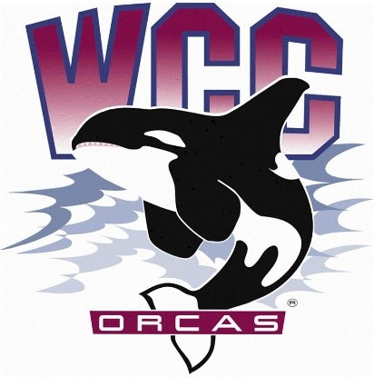
ASWCC Senate Meeting Minutes
Date: January 8th, 2024
Location: Syre 108

- Alaina Hirsch – ASWCC President, chair
Voting members
- Krystan Andreason – ASWCC VP for Campus Advocacy
- Matthew Valencia – ASWCC VP for Clubs
- Bella Nguyen – ASWCC VP for Operations, minutes taker
- Aydin Aliseo – ASWCC Senator
- Sara Rohner – ASWCC Senator
- Jovanka Wong – ASWCC Senator
- Devin Luna – ASWCC Senator
- Dansie Howard – ASWCC Senator
- Hans Nelson – ASWCC Senator
- Elizabeth Nazarova – ASWCC Senator
Meeting called to order at 3 pm
Land Acknowledgement and Pronoun Statement
Introduction of Executive Board and Senators
Procedures
Approval of meeting minutes
- Dansie moved to approve the meeting minutes from 11/27 - Devin seconded.
- Unanimous vote to approve the meeting minutes from 11/27.
Approval of agenda
- Krystan moved to approve the agenda with the stipulation that future meeting agenda would include tabled funding request – Devin seconded.
- Unanimous vote to approve the agenda with the stipulation.
ASWCC Reports
ASWCC Health & Wellness Committee
- Reminder about the next meeting the following day, 1/9/24, at 9:30 am in Syre 216.
- The committee members will continue the conversation about the Food Fight challenge and the planning of cookies, condoms, and consent; Still looking into more healthy food option (potentially via vending machines) at the Learning Commons.
ASWCC Social Justice Committee
- Reminder about the next meeting on 1/16/24, at 9:30 am in Syre 216.
- Continue the topic about the Safe Zone project, space planning request for the gender inclusive bathrooms, and planning for the Students Leading Change Conference.
Horizon
- Still working and looking for more input for the new quarter.
S&A Fee Reports
Simpson Intercultural Center
- Over the break, ICPNs (Intercultural Center Peer Navigator) have been brainstorming ideas and themes for the Students Leading Change Conference. They also worked on renewing the website, change the graphics so that it is easier to navigate, access, and make sure that all the links work and are accessible.
- Pre-planning the events for the quarter, upcoming Talkin’ Stories on 1/24/24. Moreover, on 1/18/24, Black Student Union will be hosting a viewing party of Martin Luther King Junior’s “I Have a Dream”, from 3-4 pm in Syre 217. The IC is also doing an ASWCC Union Mixer on 1/10/24, from 12-1 pm in Syre 217.
- Over the break, 46 students had visited the IC for food assistance.
Learning Center
- Application deadline for transferring to 4-year universities are coming up and the Learning Center staff are helping the students with the application.
- For the Math Center, there are professors coming in to help with math problems, from 1-2 pm, on Monday-Thursday.
- A Leaning Center Alumni is going to present on 1/10/24 at 2 pm in the Learning Commons, they will share from the vessel, from what they have been collecting from the bottom of the ocean.
Residence Life
- Start scheduling all events for Winter quarter, like Sexual Health and Safe Relationship events. Some of the Residence Life’s advisors are also focusing on managing the budget and there are also people from the local Tax Forum coming in to help do the taxes.
Orca Athletics
- The total average GPA of each sport team for Fall quarter
  - Volleyball – 3.57 GPA
  - Men’s Basketball – 3.40 GPA
  - Women’s Basketball – 3.24 GPA
  - Men’s Soccer – 3.22 GPA
  - Women’s Soccer – 2.93 GPA
- Upcoming Men’s Basketball game day will be on 1/10/24 against Peninsula College and 1/13/24 against Shoreline College.
- There will be a Youth Night on 1/24/24, Women’s Basketball game will be at 5 pm and Men’s Basketball game will be at 7 pm against Edmonds College, along with many giveaways for youth and Orca fans.
- On 1/27/24, the winner for the Food Fight challenge will be announced, and during the half time, there will be the Dodging Hunger Dodgeball Tournament.
- On 2/7/24, athletics will collaborate with the Black Student Union for Black History Celebration night.
- Badminton club is meeting to play in the gym on Tuesdays from 1-3 pm.
- Starting 1/24/24 at 12 pm, there will be a High Intensity Interval Training Class hosted by Giovanni, and yoga classes every Thursday at 12 pm; Are all free to students who bring their Orca ID card.
Performing Arts – No representatives
Pod Leaders – No current expenditures
Budget overview and status
Special Project Conferences & Presentations Equipment & Furnishing
Allocation | $12,000 | Allocation | $20,000 | Allocation | $3,000
Balance | $10,200.00 | Balance | $11,285.00 | Balance | $1,700

New business
Meeting adjourned at 3:22 pm

