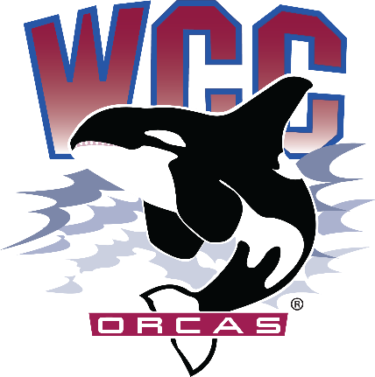
Time: 9:00 am - 10:30am
Location: Syre 216
Associated Students of Whatcom Community College (ASWCC)
InterClub Council Meeting
Meeting Agenda for Friday Oct. 27th, 2023

Call to Order
Land Acknowledgement
- Whatcom Community College is situated on the land of the Coast Salish Peoples, including the Lummi, Nooksack, Semiahmoo, and Samish. The land was stolen through broken treaties. We honor the peoples who cared and continue to care for the land, water, air, and more since time immemorial, and we recognize our responsibility in giving back and beginning to repair and rebuild relationships in our work. This is one small statement, but we hope our impact will be greater.
Pronoun Statement
- We share our pronouns to strengthen our human connection, to show respect to aspects of identity, and as an invitation for community. We understand the fluidity of identity and expression; therefore, we share pronouns in all introductions to create a supportive environment for learning and leading.

Introduction of Fully Chartered Clubs:
- Please state:
  - Name and Pronouns
  - Club you are associated with/representing
  - Your position (President, Vice President, or Club Member, etc.)
- Volleyball Club
- Campus Christian Fellowship (CCF) Club
- Sustainable Oriented Students (S.O.S) Club
- Japanese Club
- Badminton Club

Meeting Purpose
- The InterClub Council meeting serves as a platform for Chartered Clubs to collaborate, discuss funding request, share updates, and coordinate various activities to enhance the campus engagement and facilitate the growth of the ASWCC club community.

Meeting Expectations and Rules:
- Utilization of Robert's Rules of Order for a fair and structured meeting
- Use of Club name tag cards to signal a desire to speak (facing upwards)
- State your name and the club you are associated with when speaking
- Open floor for discussion before voting or when needed

Approval of Agenda:
- Motion to vote for approval
InterClub Council Budget Report
Orca Day (Reserved) Budget | (Separate Bucket) $4,000
Beginning Budget | $15,000
Projected ’23-’24 Club Allocations*  (5 clubs) | ($3,000)
InterClub Council Administrative Costs  (Food, Club Fairs, ICC and marketing) | ($1,500)
Remaining Projected Available Budget | $10,500

*This projection is based upon the total clubs chartered through Fall Quarter and assumes that each club, as per ASWCC policies, will be fulfilling their responsibilities as well as meet the incentive to roll unused funds forward.
New Business:
- Social Media Marketing
  - Club of the Week
- Other Club Initiatives (e.g., Talent Show)
- Open Floor
- Comments and Concerns to better serve Chartered Clubs

Reminders:
- Maintaining Active Status
- Next Interclub Council
  - November 17th (Funding request 1 week advance, deadline: November 10th)
- Quarterly reports
Adjourn

