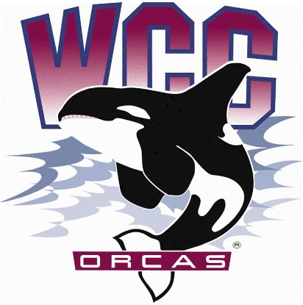
S&A Budget Review Committee Meeting Minutes
Date: March 1st, 2024
Location: Syre 216

- Alaina Hirsch – President, chair
- Heidi Farani – Advisor
Voting members
- Jovanka Wong – ASWCC Senator and ASWCC Event Support
- Krystan Andreason – ASWCC VP for Campus Advocacy
- Hans Nelson – ASWCC Executive Support Coordinator and ASWCC Senator
- Kerri B. Holferty – VP for Student Services
- Mariam Mohd – ASWCC Executive VP (minute taker)
Call to order
Approval of agenda:
- Agenda approved by a unanimous vote.
New business:
VP of Administration S&A Presentation
- Key components
  - S&A Fees are a part of tuition, alongside Operating Fees and Building Fees.
  - S&A revenue forecast for next year, as of winter quarter, is $902,700.
  - S&A current fund balance is $2,900,000.
    - $400,000 for the Orca Field.
      - The Orca Field is usually re-done every 7 years
      - This costs around $1,000,000.
- Clarifications/Observations
  - S&A budgets/allocations
    - S&A fees were increased due to legislation
    - Historically, the S&A committee would contribute 10% of the allocations to the S&A fund balance

  - Orca Field/Athletics spending
    - The Orca Field can be reserved/leased
    - Orca Athletics has gone over budget this year
    - There are no spring sports, so Orca Athletics tend to spend less in spring quarter
Performing Arts Funding Request
- Committee members looked over the Performing Arts Department S&A Funding Request of $12,893.76, and scored the request based off the ASWCC S&A Budget Committee Proposal Score Sheet
- The funding request was for student keyboard lab monitors wages and benefits
  - Clarifications
    - Minimum wage was no longer accurate and was stated to be $16.28.
    - The committee will also receive a presentation of the funding request from the Performing Arts Department
    - The request is for 20 hours a week
    - Last year, this Performing Arts Department received half of what they had requested
    - Open Lab hours would receive no operational funds
    - Open Lab employees offer music tutoring, so this could be considered as special tutoring
    - Currently offer Piano and Guitar tutoring
  - Discussion
    - It was estimated that the around 4.5 students visit weekly, which was considered to be low in regards to funding for 20 hours a week
    - Concerns were raised over student awareness of this program/lack of effective marketing
    - It was expressed how Performing Arts is an important aspect of higher education
- This funding request will be revisited
Nursing Department Pinning Ceremony Funding Request
- This year, this was funded by senate.
- S&A Committee had not funded this last year.
- Discussion
- Is this an event or program? Better for us or Senate?
- Since it happens every year, it is strange it goes to Senate.
Public Comment
Gallery members had suggestions/requests on behalf of students on campus.
- Suggestions for campus:
- Monthly food truck
- Coffee maker and microwave in Kelly Hall
- Setting up traditional Celebrations from every culture.

Adjourned

