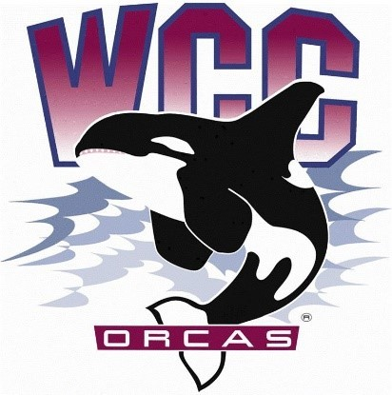
S&A Budget Review Committee Meeting Minutes
Date: March 8th, 2024
Location: Syre 216

- Alaina Hirsch – President, Chair
- Heidi Farani – Advisor
Voting members
- Jovanka Wong – ASWCC Senator and ASWCC Event Support
- Krystan Andreason – ASWCC VP for Campus Advocacy
- Hans Nelson – ASWCC Executive Support Coordinator and ASWCC Senator
- Kerri B. Holferty – VP for Student Services
- Mariam Mohd – ASWCC Executive VP (minute taker)
Call to order
Approval of agenda:
- Add ASWCC Student Government before OSLD in the Presentations (New Business)
- -Bella motioned to add introductions after call to order
- -Jovanka seconded
- Agenda approved by a unanimous vote.
New business:
- Horizon Presentation - Funding Request - Annette and Joanna - 3:13
- $16,900 request
- $4,000/quarter. Editor positions.
- $3,700 for printing
- $600 for computer and office supplies
- $200/quarter open houses. Get people connected to the Horizon.
Color copy and black and white interior quote received.
Noisy Water now under umbrella of Horizon - book publication. Open to student submissions.
KMRE partnership in the future?
Digital publication - separate from the school website - WordPress.
Instagram - attempt to gather additional readers.
3 people working for the Horizon. They want to have more.
Not just Journalism students, though that does come with some additional benefits.
-Questions
- Heidi asked about the cost associated with open house events - Refreshments and advertising.
- Mariam asked about content differences - adapting to the format but hoping to keep similar content. Annette further clarified that the focus will be on less time-sensitive reporting. (Example: Not game by game reporting, but perhaps an overview of the season)
- Krystan asked about names of graduates being included - Joananna says the intention would be to keep that element, but not as a separate spread that you can take out.

- Tanya and Yusuke - Present on Intercultural Center - 3:28
- Salary for student staff is almost the whole request
- 8 ICPNs at 14 hours.
- $92,000
- +10% wages
- $1,000 for printing: flyers and posters
- $? Programming for celebrating cultures.
Cultural Consortium membership - Partnership with other orgs to make a bigger impact.
Professional Development funding for staff - $3,000 - Most in-house
In the hopes of allowing for a little bit of travel.
Funds of excellence from the foundation previously allowed this.
Students of Color Conference - Brought 15 students.
Identity development, awareness of others, professional development for students, and social justice.
We have a conference that allows some of that knowledge to be shared (Students Leading Change)
-Questions
- Jovanka asked for training topic examples - Yuske=3 areas. Campus/Institutional Knowledge, Peer Navigating, and Social Justice and DEI component (Trainings that connect their casual conversations to support and the broader mission). Anticipate being able to open this up to all students as well.

- ASWCC Student Government - 3:40
Heidi Farani & Tanya (Unions) Presented - Executive Board and Senate explanation and Purpose
12 hired senators
Clubs and Unions
Last year, funding 3 already established student unions to have a pre-existing space for historically underrepresented students to have one without having to charter as a club.
Bylaws review committee working on edits to be submitted in spring quarter.
Explanation of Minimum Wage Calculations

Broke down costs - OASI benefits - L&I - Business office asks to calculate at 10%
Senate Budgets - See handout.
Asks for Senate Budgets have been decreased based on feedback from students.
ASWCC Club Program
Talked about pre-pandemic to post-pandemic struggle.
Money is $200/quarter.
Orca day participation funds
-Questions
- Krystan asked - Food Pantry team.
Not in ASWCC. Part of OSLD Budget.
- Kerri Asked when Min Wage comes out: Heidi says HR notifies in October.

- OSLD - 3:52 pm
Heidi and Kaleb
Student Life Engagement Team
Operational Funding - OSLD does receive some while ASWCC does not.
Food Pantry is entire calendar year rather than academic year. (52 weeks. 50/50 current min and later min wage)
10 Student Life Engagement Team Members - Breakdown of wages from training start to final week in June.
Training and Travel
Mentioned NACA and wanting to bring team or a representative.
Graphic Design Staff - Some by Engagement Team and Executive
Student Led Student Run Conferences
Kaleb - Engagement Budget
Fall Quarter
- Commencement - Cake and punch and cap decorating. 2 awards that come out of the VP office for 2 students.
- Music Licenses (2 of 4)
-Questions
- Mariam asked about $18,000 ? budget
- Kerri - Asked about FP Funding
- Jovanka - Asked about Food Pantry

Adjourned – 4:09

