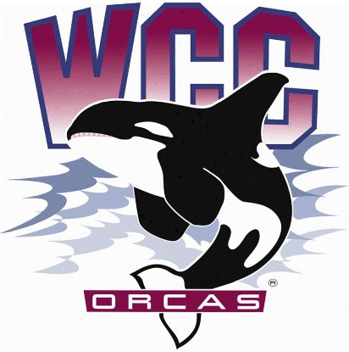
S&A Budget Review Committee Meeting Minutes
Date: March 15th, 2024
Location: Syre 216

- Alaina Hirsch – President, chair
- Kaleb Ode – Advisor
Voting members
- Kerri B. Holferty – VP for Student Services
- Jovanka Wong – ASWCC Senator and ASWCC Event Support
- Krystan Andreason – ASWCC VP for Campus Advocacy
- Hans Nelson – ASWCC Executive Support Coordinator and ASWCC Senator
- Mariam Mohd – ASWCC Executive VP (minute taker)
- Bella Nguyen – ASWCC VP for Operations
Meeting called to order at 3:01 pm
Approval if meeting minutes
- Unanimous vote to approve the meeting minutes
Approval of meeting agenda
- Unanimous vote to approve the agenda with the stipulation of adding the ASWCC Club Team funding request under New Business
New Business
Nursing Pinning Ceremony – Shannon Dunn
- Revisited the request, no questions asked
POD Leaders – Lexus Chriswell
- The POD Leaders are peer mentors, they are the first point of contact because they are based in Orca Central; Some things that POD Leaders do
- Provide referrals and resources
- Provide campus tour, engage in student orientation express enrollment
- Manage the Whatcom Alert system, to reach out to students who need help and get them back on track, reach out to faculty to give them feedback on classes and make appointments reminder for advisors. By far, they have made 400-600 phone calls
- This is not only a good resume builder, but students can also involve in college system
- Experience given from a POD Leader
- Feel satisfied when being able to help students
- Having a good knowledge of the campus resources
- Orca Central date from January - February
- 700 students came to the front desk
- 1000 phone calls were made
- 2000 students were helped in total
- They were requesting $10,000 for salaries. Clarification that they also receive operational funding, but with S&A funding, they can work for more hours. A POD Leader can work from 9-15 hours a week
- How to know when to use Operational funding or S&A funding? – The POD Leaders are currently using S&A fee
- Concerns around S&A fee being used for express enrollment since some students may not be WCC students yet
- How to get to POD Leaders? – They are at the front desk of Orca Central
Learning Center – Jason Babcock
- Brief overview about the Learning Center tutors
- Drop-in tutor for classes like STEM, Math, English, resume writing… for students
- 1 on 1 tutoring for classes that don’t have drop-in tutor support
- Tutors here are WCC students, this will be a work opportunity for International students who cannot work off campus, students can also work with alumni and gain more experience in both work and academic
- The presentation stated that funding tutors with S&A fee was permissible because tutoring is co-curricular as outlined in the Financial Code
- Discussion ensued on whether tutoring is curricular or co-curricular
  - Counterargument was that tutoring directly supports credited classes, and therefore is curricular
- Last year, the building was supposed to be opened for more hours but had to cut down some because of the cut in budget. If the building have more flexible hours, labs can open more hours, nursing help, can serve more students…
- A survey carried out in 2023 asking graduated students about their experiences at the Learning Center, many of that mention the good quality of the tutors
- They were requesting for $80,000, only to support students salaries and staff training
- Had to consider these factors
- The wages went up 72%
- The request compared to 2014 went up 14%
- Hours increase 27%
- With 60 tutors, how many are consistent? – Some come in and then leave, around 50 are consistent
- Are the tutors all WCC students? No, some are graduated, they often come to help with hard subjects
- Was there a cut in last year Operational Budget? – No, received a flat fund with COLA (Cost of Living Adjustment), had to compensated for less S&A funding with only $16,000
- Concerns from the voting members
- Paying additional funds when this should have already been covered in cost for class success
- Counterargument that tutoring was not critical
- Gallery comment
- Student advocated for the amount of impact tutor center had in building community
ASWCC Club Team – Heidi Farani – Director for Student Life and Development and Matthew Valencia – ASWCC VP for Clubs
- Budget amendment for this year’s S&A budget
- The rationale was that the funding request for ASWCC Clubs and Unions Showcase was taken to the InterClub Council, but not enough voting were there so the funding request weren’t approve
- Were hoping to re-allocate $4,855 from the Club budget to the Student Life and Engagement Team budget
- Unanimous vote to approve the amendment from the voting members
- Unanimous vote to approve the amendment from the Executive Board
- 4 yes
- 1 abstained
Public Comment
- Concern about the statement that tutoring is not critical
- Reminder to consider the amount requested and the available budget. Looking more into what is permissible and what is aligned with the Financial Code; Moreover, take into account that International and Running Start students don’t pay S&A fee
Unanimous vote to adjourn
Meeting adjourned

