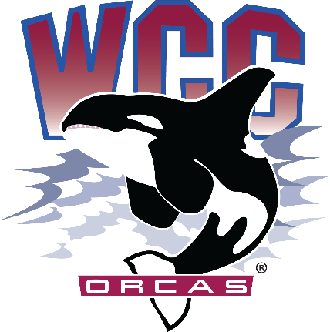
Time: 1:00pm – 2:30pm
Location: Syre 216 Associated Students of Whatcom Community College (ASWCC)
InterClub Council Meeting
Meeting Agenda for Monday April 8th, 2024

Call to Order
Land Acknowledgement
- Whatcom Community College is situated on the land of the Coast Salish Peoples, including the Lummi, Nooksack, Semiahmoo, and Samish. The land was stolen through broken treaties. We honor the peoples who cared and continue to care for the land, water, air, and more since time immemorial, and we recognize our responsibility in giving back and beginning to repair and rebuild relationships in our work. This is one small statement, but we hope our impact will be greater.

Pronoun Statement
- We share our pronouns to strengthen our human connection, to show respect to aspects of identity, and as an invitation for community. We understand the fluidity of identity and expression; therefore, we share pronouns in all introductions to create a supportive environment for learning and leading.

Meeting Purpose
- The InterClub Council meeting serves as a platform for Chartered Clubs to collaborate, discuss funding requests, share updates, and coordinate various activities to enhance the campus engagement and facilitate the growth of the ASWCC club community.

Introduction of Fully Chartered Clubs and Roll Call:
  - Please state:
    - Name and Pronouns
    - Club you are associated with/representing
    - Your position (President, Vice President, or Club Member, etc.)
    - Are you the voting member today?
    - Spring Quarter Updates
  - Volleyball Club
  - Campus Christian Fellowship (CCF) Club
  - Sustainable Oriented Students (S.O.S) Club
  - Japanese Club

  - Badminton Club
  - Native & Indigenous Student Association (NISA)
  - Robotics Club

Meeting Expectations and Rules:
  - Utilization of Robert's Rules of Order for a fair and structured meeting
    - Brief Overview of Roberts Rules
  - Use of Club name tag cards to signal a desire to speak (Stand on End) and chair will identify club
  - Raise your hand or use your Club Nametag to show a desire to speak every time, please state name and club representation please
  - Open floor for discussion before voting or when needed

Approval of Agenda:
- ICC Meeting Minutes (Feb. 15th)
- Motion to vote for approval of Agenda
*This projection is based upon the total clubs chartered through Fall Quarter and assumes that each club, as per
InterClub Council Budget Report
Orca Day (Reserved) Budget | (Separate Bucket) $4,000
Beginning Budget | $15,000
Projected ’23-’24 Club Allocations*  (7 clubs) | ($1,400)
InterClub Council Administrative Costs  (Food, Club Fairs, ICC and marketing) | ($1,500)
Fall Club Expenditures from allocations | $213.06
Winter Club Expenditures from allocations | $0
Sustainability Oriented Students Funding allocation | $2271
ASWCC Club Showcase Funding Allocation | $4,855
Remaining Projected Available Budget | $4,760.94
ASWCC policies, will be fulfilling their responsibilities as well as meet the incentive to roll unused funds forward.

New Business:
- ASWCC Club Showcase (April 16th 3:30pm – 6:30pm)
- Orca Day (Them Idea, Allocation Discussion) June 5th

ICC Meeting times for Spring Quarter:
April 22nd 1:00pm – 2:30pm Syre 216
May 6th 1:00pm – 2:30pm Syre 216
May 20th 1:00pm – 2:30pm Syre 216

Google Form Due Today for participation in ASWCC Club Showcase

Reminders/Comments/Concerns:
- End of Quarter Report or Intent to return Packets due Friday May 31st
- Fiscal Deadline all Action forms for purchase/plan purchase due April 19th
- Comments and Concerns to better serve Chartered Clubs
- Adjourn

