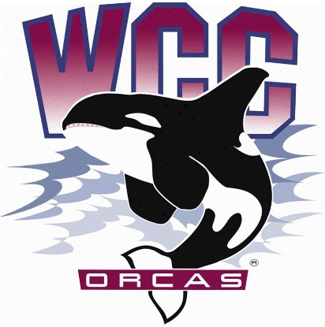
S&A Fee Budget Committee Meeting Minutes
Date: April 26th, 2024
Location: Syre 216

- Alaina Hirsch – President, chair
- Heidi Farani – Director for Student Life and Development, advisor
Voting members present
- Yusuke Okazaki - Associate Director for Intercultural Services
- Jovanka Wong – ASWCC Senator and Student Life and Engagement Specialist
- Krystan Andreason – ASWCC VP for Campus Advocacy
- Hans Nelson – ASWCC Executive Support Coordinator and ASWCC Senator
- Mariam Mohd – ASWCC Executive VP
- Kerri B. Holferty – VP for Student Services
6 out of 6 voting members present, quorum met
Votes needed for simple majority: 4
Meeting called to order at 3:05 pm
Approval of meeting minutes
- Hans moved to approve the meeting minutes from 4/5 and 4/12 – Jovanka seconded
- Unanimous vote to approve the meeting minutes from 4/5 and 4/12
Approval of agenda
- Mariam moved to approve the agenda – Hans seconded
- Unanimous vote to approve the agenda
New Business
Intercultural Center Memorandum – Yusuke Okazaki
- The Intercultural Center would like to request to amend the current budget to move $2000.00 from the allocation for wages to the programming budget. This will cover the cost the upcoming events until the rest of the academic year
- Motion to approve from the S&A Fee Budget Committee
- Krystan moved to approve the Intercultural Center Memorandum – Hans seconded
- 5 Yes, 0 No, unanimous vote to approve the Intercultural Center Memorandum
- Motion to approve from the Executive Board
- Bella moved to approve the Intercultural Center Memorandum – Mariam seconded
- 5 Yes, 0 No, unanimous vote to approve the Intercultural Center Memorandum
Office of Student Life and Development Memorandum – Alaina Hirsch and Heidi Farani
- The OSLD and the ASWCC President requested to reallocate $12,000.00 from the Executive Board salary savings for the purpose of supplies. This is because the Senate won’t have any more meetings to allocate funds and the student leaders are in the process of planning a gaming alcove on Syre second floor.
- This money will cover the expenses of TV, TV stands, new chairs, game consoles. etc.
- Clarification that even though the furniture will be requested, because of the purchasing deadline it may not happen
- Motion to approve from the S&A Fee Budget Committee
- Mariam moved to approve the OSLD Memorandum – Kerri seconded
- 6 Yes, 0 No, unanimous vote to approve the OSLD Memorandum
- Motion to approve from the Executive Board
- Matthew moved to approve the OSLD Memorandum – Krystan seconded
- 4 Yes, 0 No, unanimous vote to approve the OSLD Memorandum
Budget Deliberation
- S&A Fee increase
- The state is allowing up to 3% increase; The committee can decide to increase fee up to 3%
- Krystan moved to approve the 3% increase – Yusuke seconded
- 6 Yes, 0 No, unanimous vote to approve the 3% increase
- The committee members go through 3 options for 24-25 S&A Fee allocation, see attachments below
- Pod Leaders
- The reason for the decrease of Pod Leaders was that they do receive operational funding, and they haven’t spent much of their S&A Fee allocation. Moreover, some of the things they do aren’t align with permissible uses of S&A Fee
- Orca Food Pantry
- The Orca Food Pantry was opened for more hours because there are salary savings from the Student Life and Engagement Team, used to hire more staff. Decreasing in allocation also means that opening hours will decrease
- Committee members agreed to focus attention on option 1, which pulls a small of $9,548.00 from reserve for further discussion
- For departments that use S&A Fee to pay student staff and also supplies, does the committee need to decide how much would go to wages and supplies now? Committee members expressed that leaving allocation up to directors may make it harder for future students to have autonomy over the process; This can be discussed more at the next meeting
- Since the pandemic, there seemed to be a trend that many departments were underspent, this also happened this year
- Acknowledged that students have worked very hard to get 2.9 million in reserve now, so have to consider while pulling from it; However, minimum wage is going up so may have to consider pulling from reserve
- Athletics haven’t had an increase in a long time, and they also don’t have a lot of funding from the operational budget. Majority of the committee members agreed athletics should be increased. Yusuke suggested decreasing 10% of Intercultural Center budget. This means $94,500.00 for Intercultural Center; And the $5,500.00 remaining, $1000.00 will go to each athletics team, and $500.00 will go to their contingency travel fee
- Increase the allocation for Orca Food Pantry from $22,508.00 to $35,000.00
- The committee had consensus regarding the changes made to option 1
- Hans moved to approve the recommendation 2024 – 2025 annual S&A Fee budget of $926,908.00 – Krystan seconded
- 6 Yes, 0 No, unanimous vote to approve the 2024 – 2025 annual S&A Fee budget of $926,908.00
Meeting adjourned at 4:58 pm

