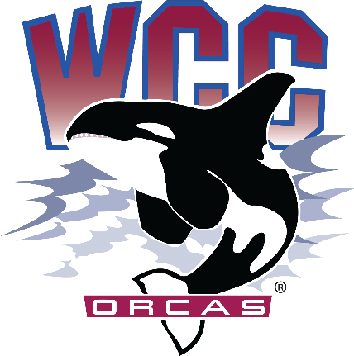
ASWCC InterClub Council Meeting Minutes
Date: May 20th, 2024
Location: Syre 216

ASWCC Club Team
- Matthew Valencia – ASWCC Vice President for Clubs, chair
- Heidi Farani – Director for Student Life and Development, advisor
- Bella Nguyen – ASWCC Vice President for Operations, minute taker
Meeting called to order at 1:05 pm
Land Acknowledgement and Pronoun Statement were read by Matthew Valencia
Overview of Meeting Purpose
Introduction of Fully Chartered Clubs and Roll Call/ Clubs Present
- Desdemonda Ruud – President for Volleyball Club, had a tournament and will have a celebration next week
- Liam Jones – President for Campus Christian Fellowship (CCF) Club, last Friday met with Western Washington University CCF Club
- Ethan Aldrich – President for Sustainability Oriented Students (S.O.S) Club, working on the campus garden and planting
- Emiline – Japanese Club, last Friday hosted a Japanese game show
- Magaly Ramos – President for Native & Indigenous Student Association (NISA), went to POWWOW in Skagit Valley College and will go on a field trip soon
- Blake Johnson – President for Robotics Club, had access to the ordered robotics kits and have been using it at club meeting, many people enjoyed it
- Luis Martinez – Vice President for Students of Color in STEM (SOCS), will host an end of year celebration on 5/28 and will have volunteer activities in Silver Beach
- Diana Kovtun – President for Rocketry & Propulsion Club, didn’t go to the last rocket launch in Tri-Cities, will go again on 6/8 and 6/9
- Eva Kaylor-McElmury - President for Philosophy Club, have meeting every Monday
- Meredith Steed – Treasurer for Criminal Justice Club, participated in a swatch training at Mount Baker High School
9 out of 12 chartered clubs present, quorum met
Votes needed for simple majority: 5
Clubs not present
- Astronomy Club
- Women in Cybersecurity (WiCys)
Review of Meeting Expectations and Rules
Approval of Meeting Minutes
- Blake moved to approve the meeting minutes from 4/22 – Ethan seconded
- Unanimous vote to approve the meeting minutes from 4/22
Approval of agenda
- Ethan moved to approve the agenda with the amendment to have an overview of next year budget under new business – Barret seconded
- Unanimous vote to approve the agenda with the amendment

New business
Orca day
- Will be on 6/5, money and space have been decided for 9 clubs
- Google form for space request is due today
Next year budget
- It will be $10,000 for next year club allocation. The S&A Fee Budget Committee has decided this since the expenditures this year wasn’t much
- Reminded clubs to turn their Intent to Return soon so that they can charter early for the next academic year, and it is better for student government to do it early too
Reminders/Comments/Concerns
- Clubs can do either Intent to Return or End of Quarter Report
- Comments to pass down for next year for next year VP for Clubs & Unions
Meeting adjourned at 1:24 pm

