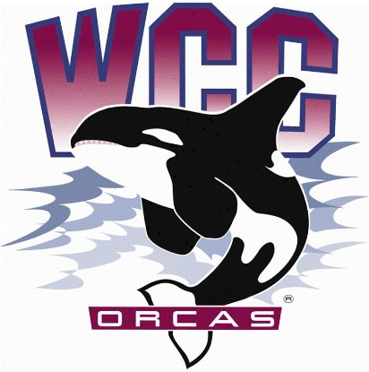
ASWCC Executive Board Meeting Minutes
Date: May 13th, 2024
Location: Syre 108
- Alaina Hirsch – ASWCC President, chair
Voting members
- Mariam Mohd – ASWCC Executive VP
- Krystan Andreason – ASWCC VP for Campus Advocacy
- Matthew Valencia – ASWCC VP for Clubs
- Bella Nguyen – ASWCC VP for Operations, minute taker
5 out of 5 Executive Board members presented, quorum met
Votes needed for simple majority: 3
Meeting called to order at 3:03 pm
Welcome, Land Acknowledgement and Pronoun Statement were read by Alaina Hirsch
Approval of meeting minutes
- Mariam moved to approve the meeting minutes from 5/13 – Krystan seconded
- Unanimous vote to approve the meeting minutes from 5/13
Approval of agenda
- Bella moved to approve the agenda – Matthew seconded
- Unanimous vote to approve the agenda
Advocacy
Faculty Excellence Award – Alaina Hirsch
- The WCC Vice President for Instruction has reached out to students for nomination for the Faculty Excellence Award, he is hoping to get at least 5
- This include a letter of support from the student, and another one from their department chair, program lead or dean
Legacy
Work Plan reflections
- Accomplishments and Recommended goals for next year
- The students did advocate for the gender neutral bathrooms to be installed in Syre Student Center and Student Recreation Center but they didn’t finish on time
- Refrigerated vending machine, this was too expensive so have managed to have students work extra hours at the Cove over in the Learning Commons
- Had the opportunity to work with the League of Women Voters to remain as a voter friendly campus
- Hope to improve more on the marketing, more flyers and more social media engagement. The flyers for the governance meetings right now look too formal, next year student leaders can ask graphic design for help with these
- Accomplished amending the ASWCC Bylaws & Constitution, completing the work of students for the past 5 years
- Got the space planning requests done
- For the ASWCC Hub App, hope that clubs and students can work with OSLD professional staff next year to get that going and have students know about it more; Suggestion for Senators to have their constituents group on their, they can text instead of sending emails
- The Walk & Talk with a Student Leader and Coffee with a Student Leaders events have been having many engagements
- Did collaborations with the counsellors to have wellness month events; Also collaborated with the ICPNs at Students Leading Change Conference
- Had the Food Fight which was not only fun but also brought back attention to the Orca Food Pantry
- For clubs, some clubs this year just wanted to be chartered and engage, for Winter quarter, $0 was spent. So next year ASWCC VP for Clubs & Unions can look more into the layering chartering process, clubs that just want to chartered to engage can be chartered earlier with less paperwork
- Disappointments
- The Orca Food Pantry refrigerated system, hasn’t looked into this much
- Explore wages increase for student staff
- Campus child policy, this was brought to the President’s Cabinet but didn’t go further than that
- Orca Volunteer Program, due to a lack of time this wasn’t accomplished
- Having arts in Syre Student Center
- Wish would have known
- Krystan – Has been informed that this position is going to be big, but it was gigantic. Hoped to have been taught more about the position and the works that are going to come along with it
- Matthew – Hoped to have learnt how to write an email
- Mariam – How to prepare for speaking with legislators, having a strong understanding
- Alaina – Think that now looking back, the work plan was too ambitious; Wish to have looked more into S&A Fee for international students and running starts, and the arts in Syre
- Bella – Wish had known more about the work and have someone to go over that with
- What did well
- Bella – Worked well in a team and learned the importance of teamwork
- Alaina – Didn’t have much knowledge about the position, but did a good work creating and managing it throughout the year
- Mariam – Talked about legislative issues that don’t even apply to her, but did good with that
- Matthew – Hapy about the job shadowing, get to hand all the information and experience to next year position
- Krystan – Learned how to use her voice and made sure that she is heard
Public comments
- Alaina gave update on the 24-25 S&A Fee Budget Proposal, this has been approved by the Executive Board, the next step will be the approval from the Board of Trustees
- Student athletes shared their experience and reasons why they need more allocation
- The athletes also do many recruitments, these bring more students and money to the college. Moreover, the allocation for athletics hasn’t been increased since 2013. The uniforms aren’t new and updates, there aren’t many varied sizes, some athletes cannot play well since their uniform is too small
- Being an athlete meaning having the chance to meet many people around the world. If the allocation is increased, international students can come and engage in college life. This also means more opportunity to provide scholarship to student athletes. If the allocation is decreased, it will restrict the potential to go and recruit new members
- The athletes have to wake up early in the morning to do practice, then go to class, do jobs off campus and also have to do fundraise. The fundraising usually covers for the games, basic operations, photos, etc.
Adjourn
- Alaina moved to adjourn – Hans seconded
- Unanimous vote to adjourn
Meeting adjourned at 3:54 pm

