Steps for Requesting Captioned Media through MyADS Faculty Portal

- Start at www.whatcom.edu/access and using your WCC credentials log into MyADS Faculty Portal located in the right column under RELATED LINKS. You will arrive at the Instructor Authentication Page.

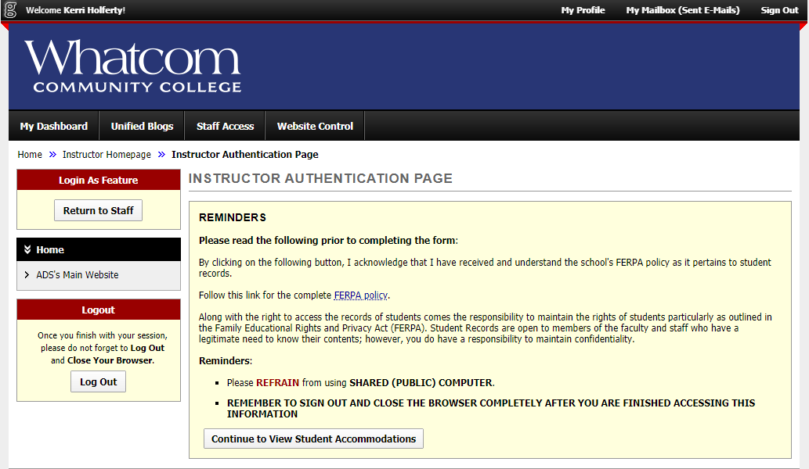

- Please read through the box titled Reminders. Once you are finished, click the “Continue to View Student Accommodations” button

- Navigate to the left side of the page where you will find a section titled Views and Tools: Click on “Deaf and Hard of Hearing”
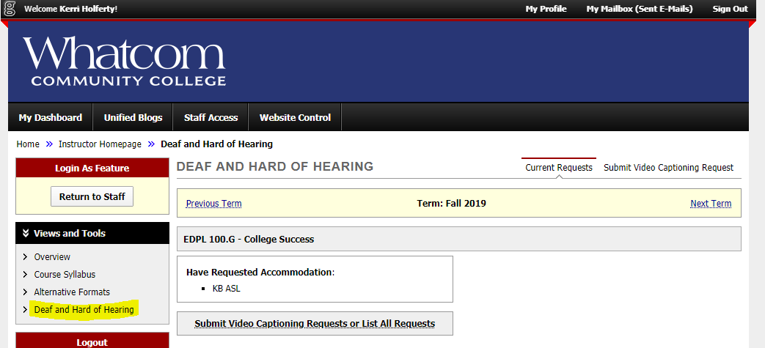

- Under the course name, click on “Submit Video Captioning Requests”
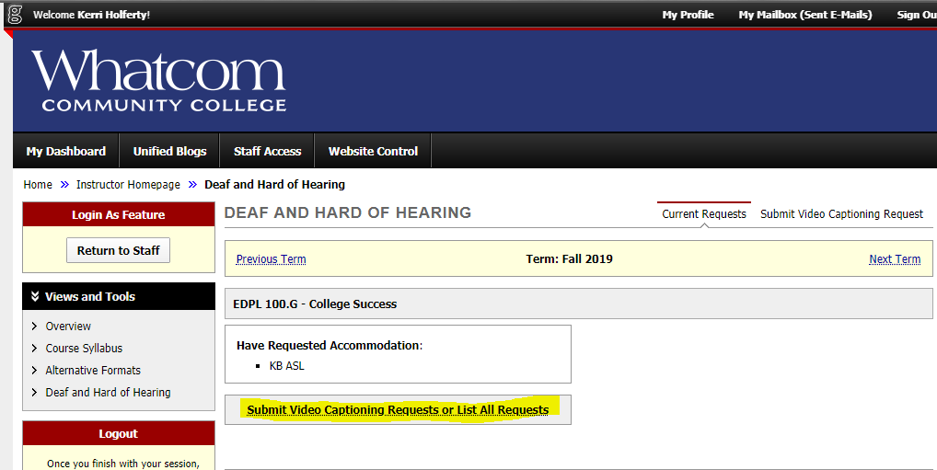

- Complete the fields in the form. Once you have reviewed the form, you may submit it by clicking the “Add Video List” button at the bottom.
