If the video is in YouTube or Panopto, it can be submitted through CaptionHUB for captioning at a reduced rate.

Follow these steps to request your videos be captioned:

How to Use Caption HUB

1. You can find the Caption HUB tab in your Canvas course Navigation:

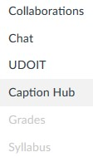

1. When you click on the Caption Hub tab it will take you to a Caption Request page:

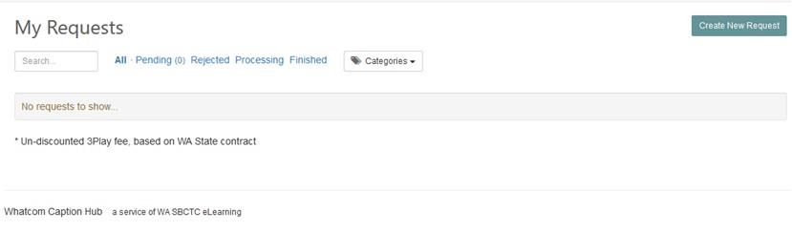

1. Click the ‘Create New Request’ button & fill in as much as you can. Be sure to select the correct video format (YouTube or Panopto)

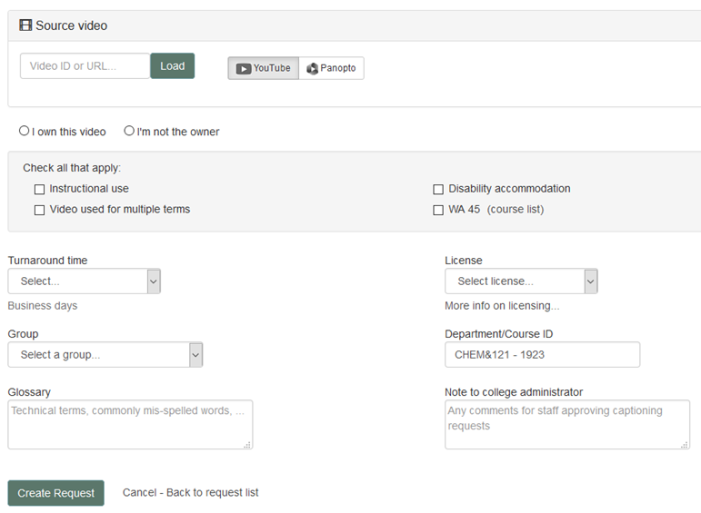

# Things to know:

* Currently Caption Hub only accepts YouTube & Panopto video links.
  + If your video is in a format or location other than YouTube or Panopto, please complete the [Captioning Request form](http://fidalgo/ADS/Request%20for%20Captioned%20Media_ADAC%202018Jan.docx) and send to Kerri Holferty in the ADS office. Your video will still be able to be captioned.
* Please choose & allow for 10-day turnaround.
* If you are not the owner of the video, your video can still be captioned.
* If your video meets all four categories listed, it will be captioned for free. If it meets 1-3 of the categories listed, it will be discounted accordingly.
* For the Group option – please choose non-instructional or instructional.
* You can leave us a message in the Note to College Administrator box.

If you have any questions about the captioning process or Canvas, contact Tye Durbin [tdurbin@whatcom.edu](mailto:tdurbin@whatcom.edu)

If you have any questions about accommodations or the ADS process, contact Kerri Holferty, [kholferty@whatcom.edu](mailto:kholferty@whatcom.edu)